Hedged Mean Reversion Strategy - Nasdaq & Dow Jones Correlation - Historical Market Data Analysis (R)

Krzysztof Strzelec

2025-01-19

# Quantitative Trading Analysis Documentation

## Setup Environment

### Purpose

The environment setup ensures that the necessary tools for quantitative trading analysis are readily available. This robust setup facilitates data manipulation, exploratory data analysis (EDA), financial computations, statistical modeling, and visualization—all essential components of high-level quantitative research.

### Libraries and Tools

The script utilizes a diverse array of R libraries, including but not limited to:

* **Financial Data and Analysis:** quantmod, TTR, PerformanceAnalytics, ROI, quantstrat
* **Data Manipulation:** dplyr, data.table, tidyquant, zoo, xts, reshape2
* **Visualization:** ggplot2, plotly, ggcorrplot, dygraphs, RColorBrewer
* **Machine Learning and Forecasting:** caret, forecast
* **Reporting and Documentation:** rmarkdown, bookdown, knitr

The libraries quantstrat and blotter enable advanced portfolio backtesting and simulation, a key requirement for the development and evaluation of the hedged mean-reversion strategy.

### Robustness Check

The setup script includes functionality to: 1. **Verify package installation:** Installs missing packages automatically. 2. **Support advanced tools:** Ensures GitHub packages (blotter and quantstrat) are installed using devtools. 3. **Provide reproducibility:** Loads all libraries systematically for a consistent working environment.

The setup script concludes with a confirmation message: "All packages have been installed and loaded successfully."

## Data Handling and Analysis

### Exploratory Data Analysis (EDA)

EDA is the cornerstone of quantitative research, enabling a deep understanding of historical data patterns, anomalies, and trends.

#### Dow Jones and Nasdaq Closing Prices

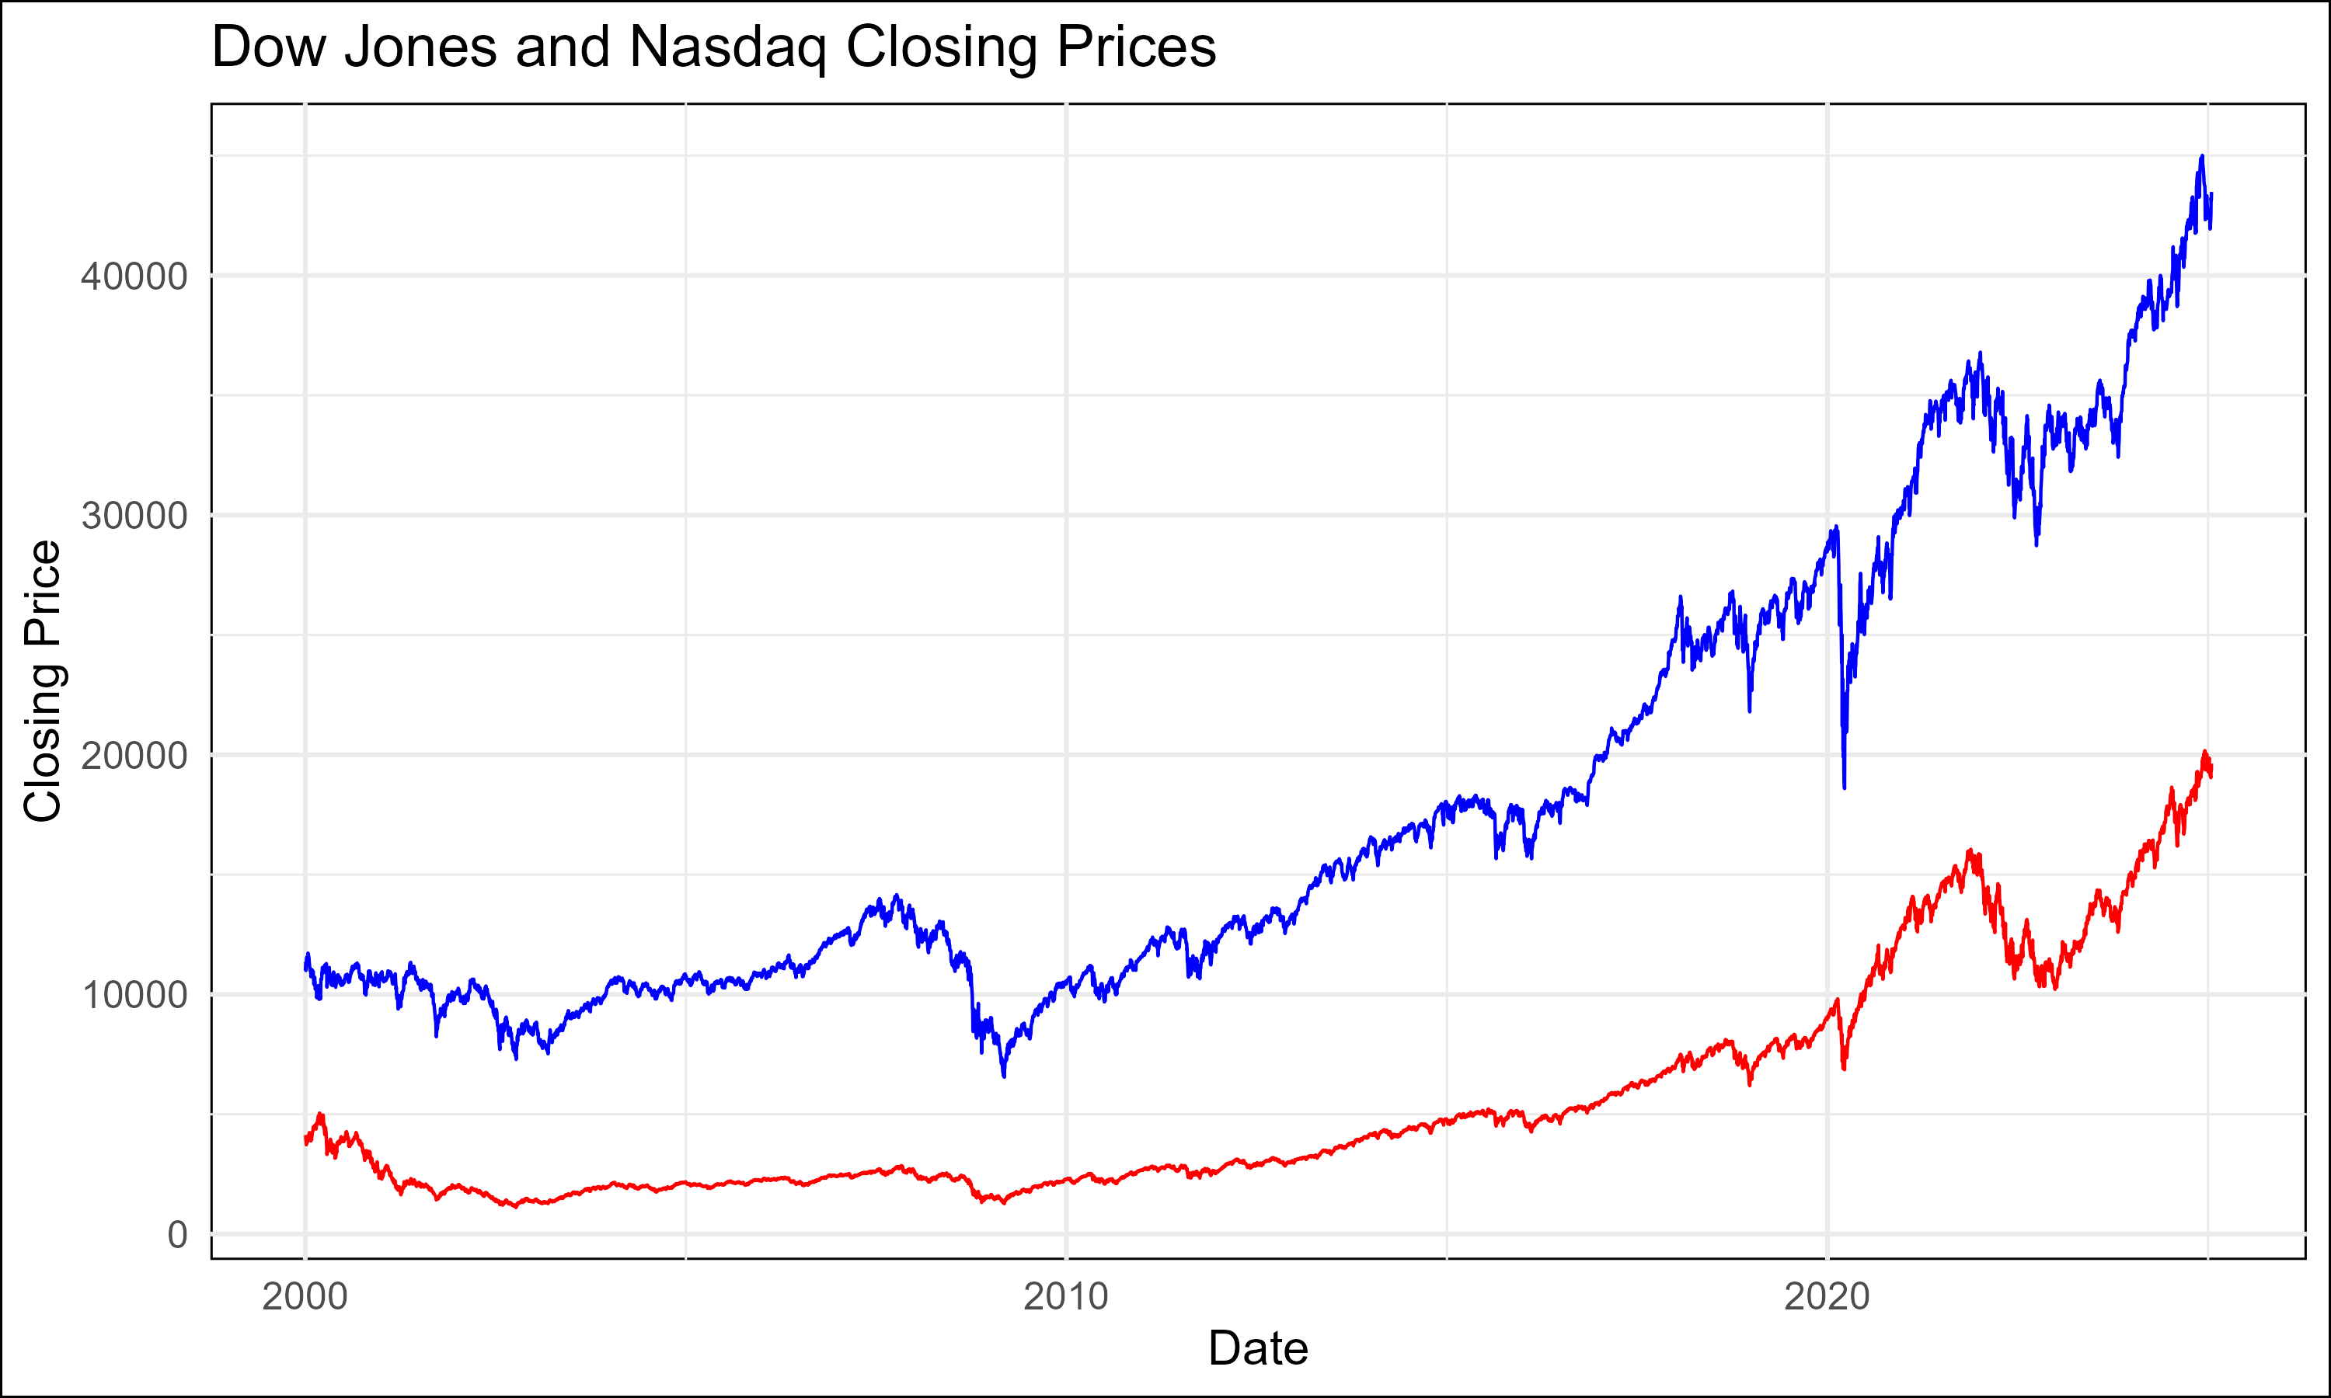

Closing Prices

This plot illustrates the historical closing prices of the Dow Jones Industrial Average (DJIA) and Nasdaq Composite Index from 2000 to 2024. Key observations include:

* **Trends:** Both indices show a general upward trajectory over the long term, reflecting economic growth and technological advancements.
* **Volatility Differences:** The Nasdaq exhibits higher volatility compared to the Dow Jones, particularly during periods like the dot-com bubble (2000-2002) and the COVID-19 pandemic (2020).
* **Divergence Opportunities:** Temporary divergences between the two indices highlight potential mean-reversion opportunities. For example:
  + During the 2008 financial crisis, the Nasdaq experienced a sharper decline than the Dow, suggesting differing sensitivities to market shocks.

##### Analytical Implications

Understanding these price dynamics is critical for: 1. **Identifying Mean Reversion Signals:** Pinpointing periods where the gap between indices widens beyond historical norms. 2. **Evaluating Risk Profiles:** Recognizing the Nasdaq’s higher volatility helps refine strategy parameters to balance risk and reward. 3. **Corroborating Hypotheses:** The consistent correlation between these indices forms the foundation of the hedged mean-reversion strategy.

##### Quantitative Enhancements

To deepen insights, further analyses could include: - **Seasonal Adjustments:** Analyze how seasonal factors (e.g., earnings seasons, holidays) affect price movements. - **Macro Indicators Overlay:** Correlate price trends with economic indicators (e.g., GDP growth, interest rates).

#### Histogram of Daily Returns

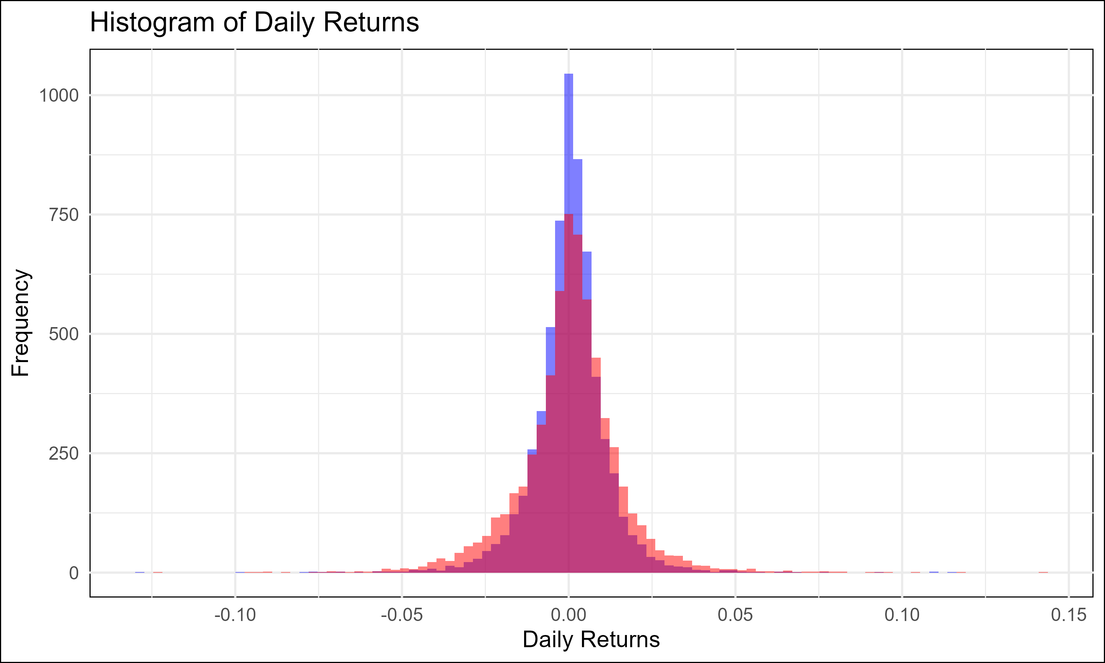

Histogram of Daily Returns

The histogram provides a detailed visualization of the daily returns distribution for the Dow Jones Industrial Average (DJIA) and Nasdaq Composite Index. The blue bars represent DJIA returns, while the red bars represent Nasdaq returns. This representation is crucial for understanding the behavioral characteristics of each index under varying market conditions.

### Analysis of the Histogram

1. **Return Distribution Characteristics:**
   * **Dow Jones (DJIA):** The distribution of daily returns for DJIA is narrower, indicating lower volatility and more predictable price movements. This is consistent with its composition of well-established, blue-chip companies.
   * **Nasdaq Composite:** The Nasdaq exhibits a broader and flatter distribution, reflecting higher volatility, which aligns with its concentration in technology and growth stocks.
2. **Skewness:**
   * Both indices exhibit a slight negative skewness, as seen from the longer left tails of the histogram. This suggests that extreme negative returns (e.g., during market crashes) are more likely than extreme positive returns.
3. **Kurtosis (Fat Tails):**
   * The Nasdaq displays heavier tails compared to the DJIA. This implies a higher likelihood of extreme movements, underscoring the need for risk management, particularly in a hedged strategy.
4. **Relative Behavior in Normal Market Conditions:**
   * The clustering of returns around the mean suggests that both indices tend to revert to their respective averages over time. This characteristic is pivotal for the success of a mean-reversion strategy.

### Implications for the Hedged Mean Reversion Strategy

1. **Volatility Management:**
   * The Nasdaq’s higher volatility demands adjustments in position sizing to ensure that the hedge remains balanced.
   * Volatility-weighted capital allocation could mitigate the impact of extreme movements in either index.
2. **Outlier Sensitivity:**
   * The presence of outliers necessitates safeguards such as temporary halts during extreme divergence. This ensures that the strategy capitalizes on reversion opportunities without being derailed by rare, unpredictable events.
3. **Return Clustering:**
   * The clustering behavior of returns reinforces the viability of identifying correlation extremes and initiating trades that exploit eventual reversion to the mean.

#### Descriptive Statistics for Closing Prices

Descriptive statistics provide a foundational understanding of the historical performance and variability of each index. This data is critical for calibrating the mean-reversion model.

* **Dow Jones Industrial Average (DJIA):**
  + Minimum: **6547.05**
  + 1st Quartile: **10604.19**
  + Median: **13390.94**
  + Mean: **18006.78**
  + 3rd Quartile: **25001.51**
  + Maximum: **45014.04**
* **Nasdaq Composite Index (IXIC):**
  + Minimum: **1114.11**
  + 1st Quartile: **2187.78**
  + Median: **3318.765**
  + Mean: **5480.902**
  + 3rd Quartile: **7481.803**
  + Maximum: **20173.89**

### Analysis of Closing Prices

1. **Trend and Growth:**
   * Both indices exhibit long-term upward trends, reflecting economic expansion, technological innovation, and favorable macroeconomic conditions over the 2000-2024 period.
   * The Nasdaq’s rapid growth from a minimum of 1114.11 to a maximum of 20173.89 highlights its outperformance, albeit with higher associated risk.
2. **Quartile Insights:**
   * The interquartile range (IQR) for the DJIA is narrower compared to the Nasdaq, underscoring its relatively stable performance.
   * The Nasdaq’s broader IQR reflects higher variability and speculative trading behavior, which is a key driver of its divergence from the DJIA.
3. **Divergence Opportunities:**
   * The significant differences in price dynamics between the two indices create regular opportunities for mean-reversion trades, particularly when one index deviates substantially from its historical relationship with the other.

#### Descriptive Statistics for Daily Returns

* **Dow Jones Industrial Average (DJIA):**
  + Minimum: **-0.1292655**
  + 1st Quartile: **-0.0045716**
  + Median: **0.0005018**
  + Mean: **0.0002787**
  + 3rd Quartile: **0.0056029**
  + Maximum: **0.1136504**
* **Nasdaq Composite Index (IXIC):**
  + Minimum: **-0.1232133**
  + 1st Quartile: **-0.0063574**
  + Median: **0.0009132**
  + Mean: **0.0003686**
  + 3rd Quartile: **0.0077592**
  + Maximum: **0.1417320**

### Analysis of Daily Returns

1. **Central Tendency:**
   * The mean daily return for Nasdaq (**0.0003686**) is higher than that of DJIA (**0.0002787**), reflecting its long-term growth potential.
   * Positive medians for both indices indicate a general upward bias over the long term, aligning with equity market expectations.
2. **Volatility Comparison:**
   * The Nasdaq’s wider range of daily returns (-0.1232133 to 0.1417320) versus the DJIA (-0.1292655 to 0.1136504) confirms its higher volatility and greater potential for divergence during periods of market stress.
3. **Quartile Insights:**
   * The DJIA’s narrower interquartile range (IQR) indicates more consistent day-to-day performance compared to the Nasdaq.
4. **Tail Events:**
   * Both indices have extreme negative returns in their respective minima, which correspond to significant market drawdowns. These events underscore the need for hedging and risk management in the strategy.

### Implications for the Hedged Mean Reversion Strategy

1. **Volatility-Driven Hedging:**
   * The volatility disparity between indices necessitates dynamic adjustments to ensure the hedge ratio remains effective. For example, scaling down Nasdaq exposure during high-volatility periods reduces residual risk.
2. **Convergence Opportunities:**
   * The clustering of daily returns around the mean supports the premise of reversion, providing confidence in the strategy’s profitability when exploiting divergence extremes.
3. **Risk-Adjusted Optimization:**
   * Higher mean and variance in Nasdaq returns suggest the need for advanced metrics (e.g., volatility-adjusted spreads) to refine entry and exit criteria.
4. **Scenario Planning:**
   * Extreme values (tails) highlight the importance of incorporating safeguards against correlation breakdowns, such as stop-loss mechanisms for persistent divergences.

### Annual Returns of Dow Jones and Nasdaq

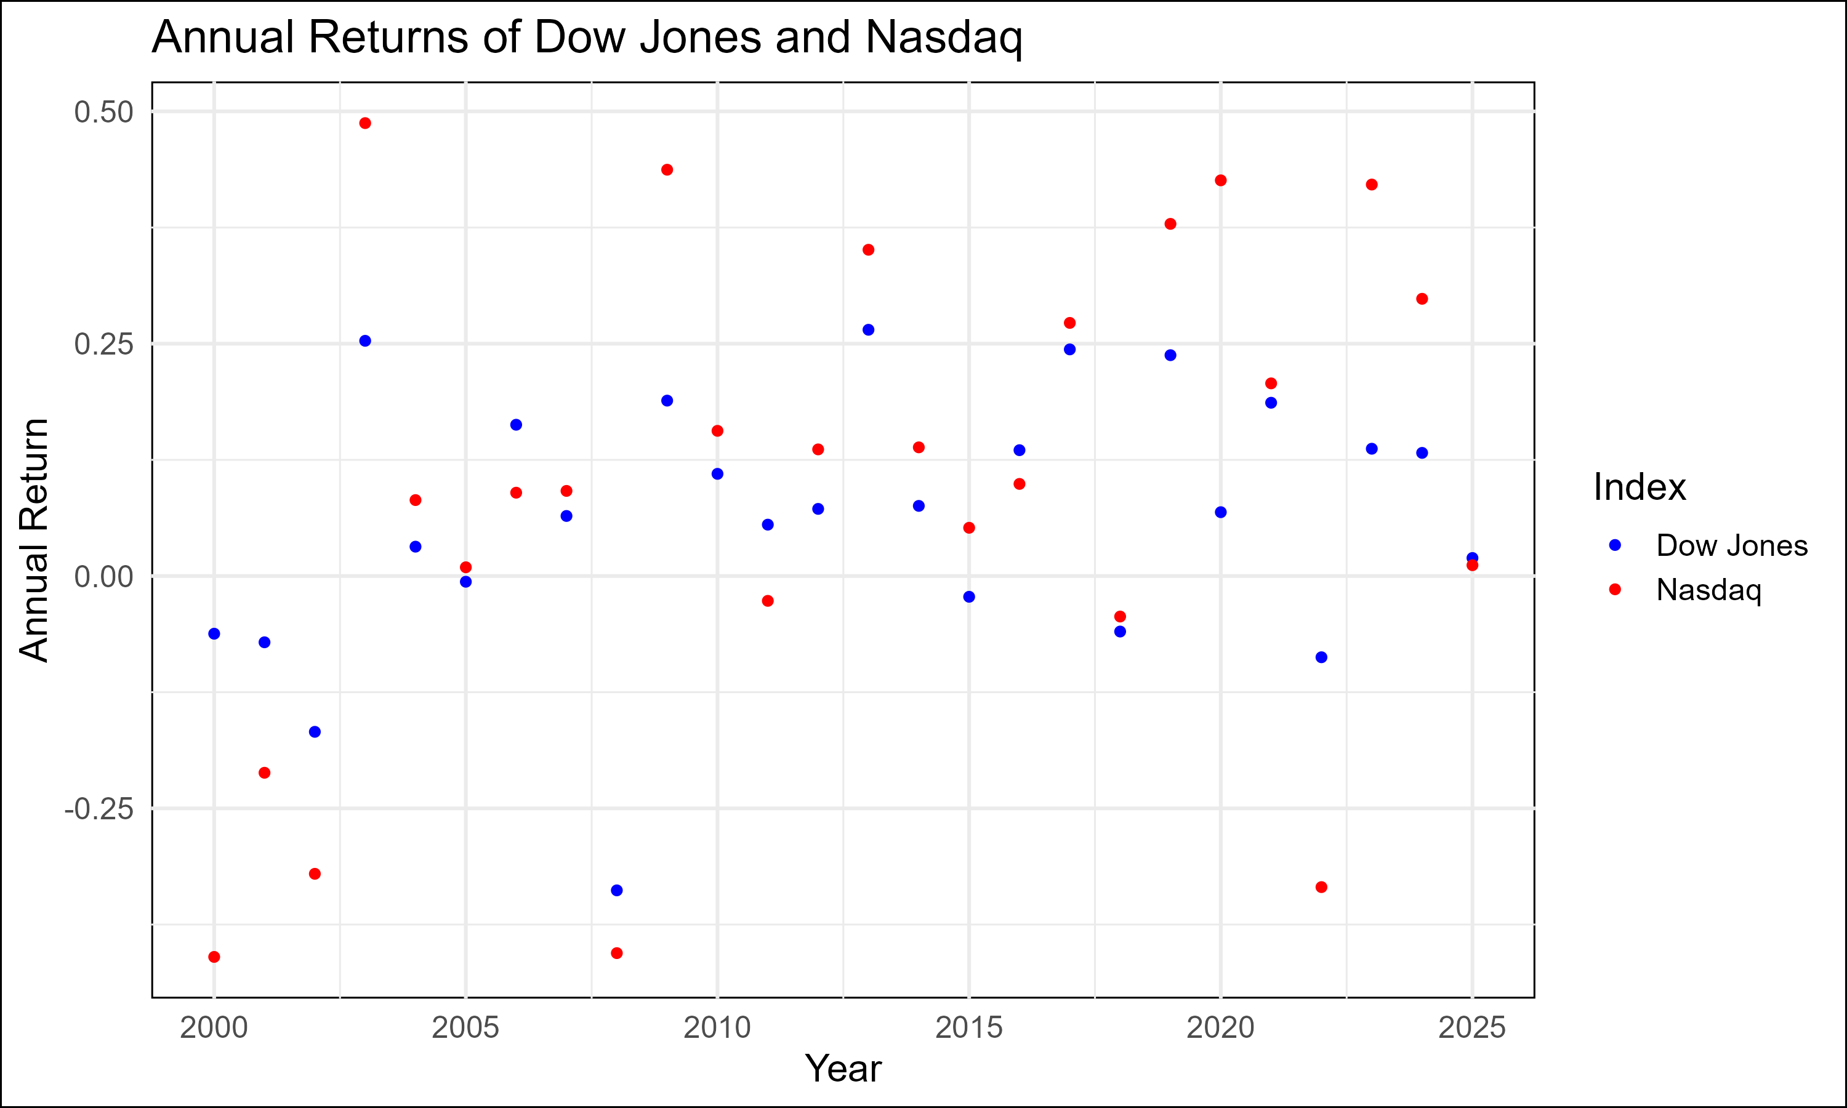

Annual Returns

The scatter plot of annual returns offers a comprehensive view of the year-over-year performance for the Dow Jones Industrial Average (DJIA) and Nasdaq Composite Index. Each data point represents the annual return for a specific year, with blue points corresponding to the DJIA and red points to the Nasdaq.

#### Analysis of Annual Returns

1. **Trend Analysis:**
   * The DJIA exhibits relatively stable annual returns, indicative of its composition of mature, large-cap companies with consistent performance over time.
   * The Nasdaq shows greater variability in annual returns, reflecting its concentration in technology and growth sectors, which are more sensitive to macroeconomic conditions and innovation cycles.
2. **Return Extremes:**
   * The Nasdaq experiences higher peaks and deeper troughs compared to the DJIA. For instance, during technology booms or busts, the Nasdaq’s performance significantly diverges from that of the DJIA.
3. **Hedged Mean-Reversion Insights:**
   * The annual return divergence between the two indices underscores the potential for identifying mean-reversion opportunities, particularly during years of extreme outperformance or underperformance by one index.
4. **Long-Term Growth:**
   * Both indices show a general upward drift in annual returns over the sample period, consistent with historical market growth.

### Monthly Returns of Dow Jones and Nasdaq

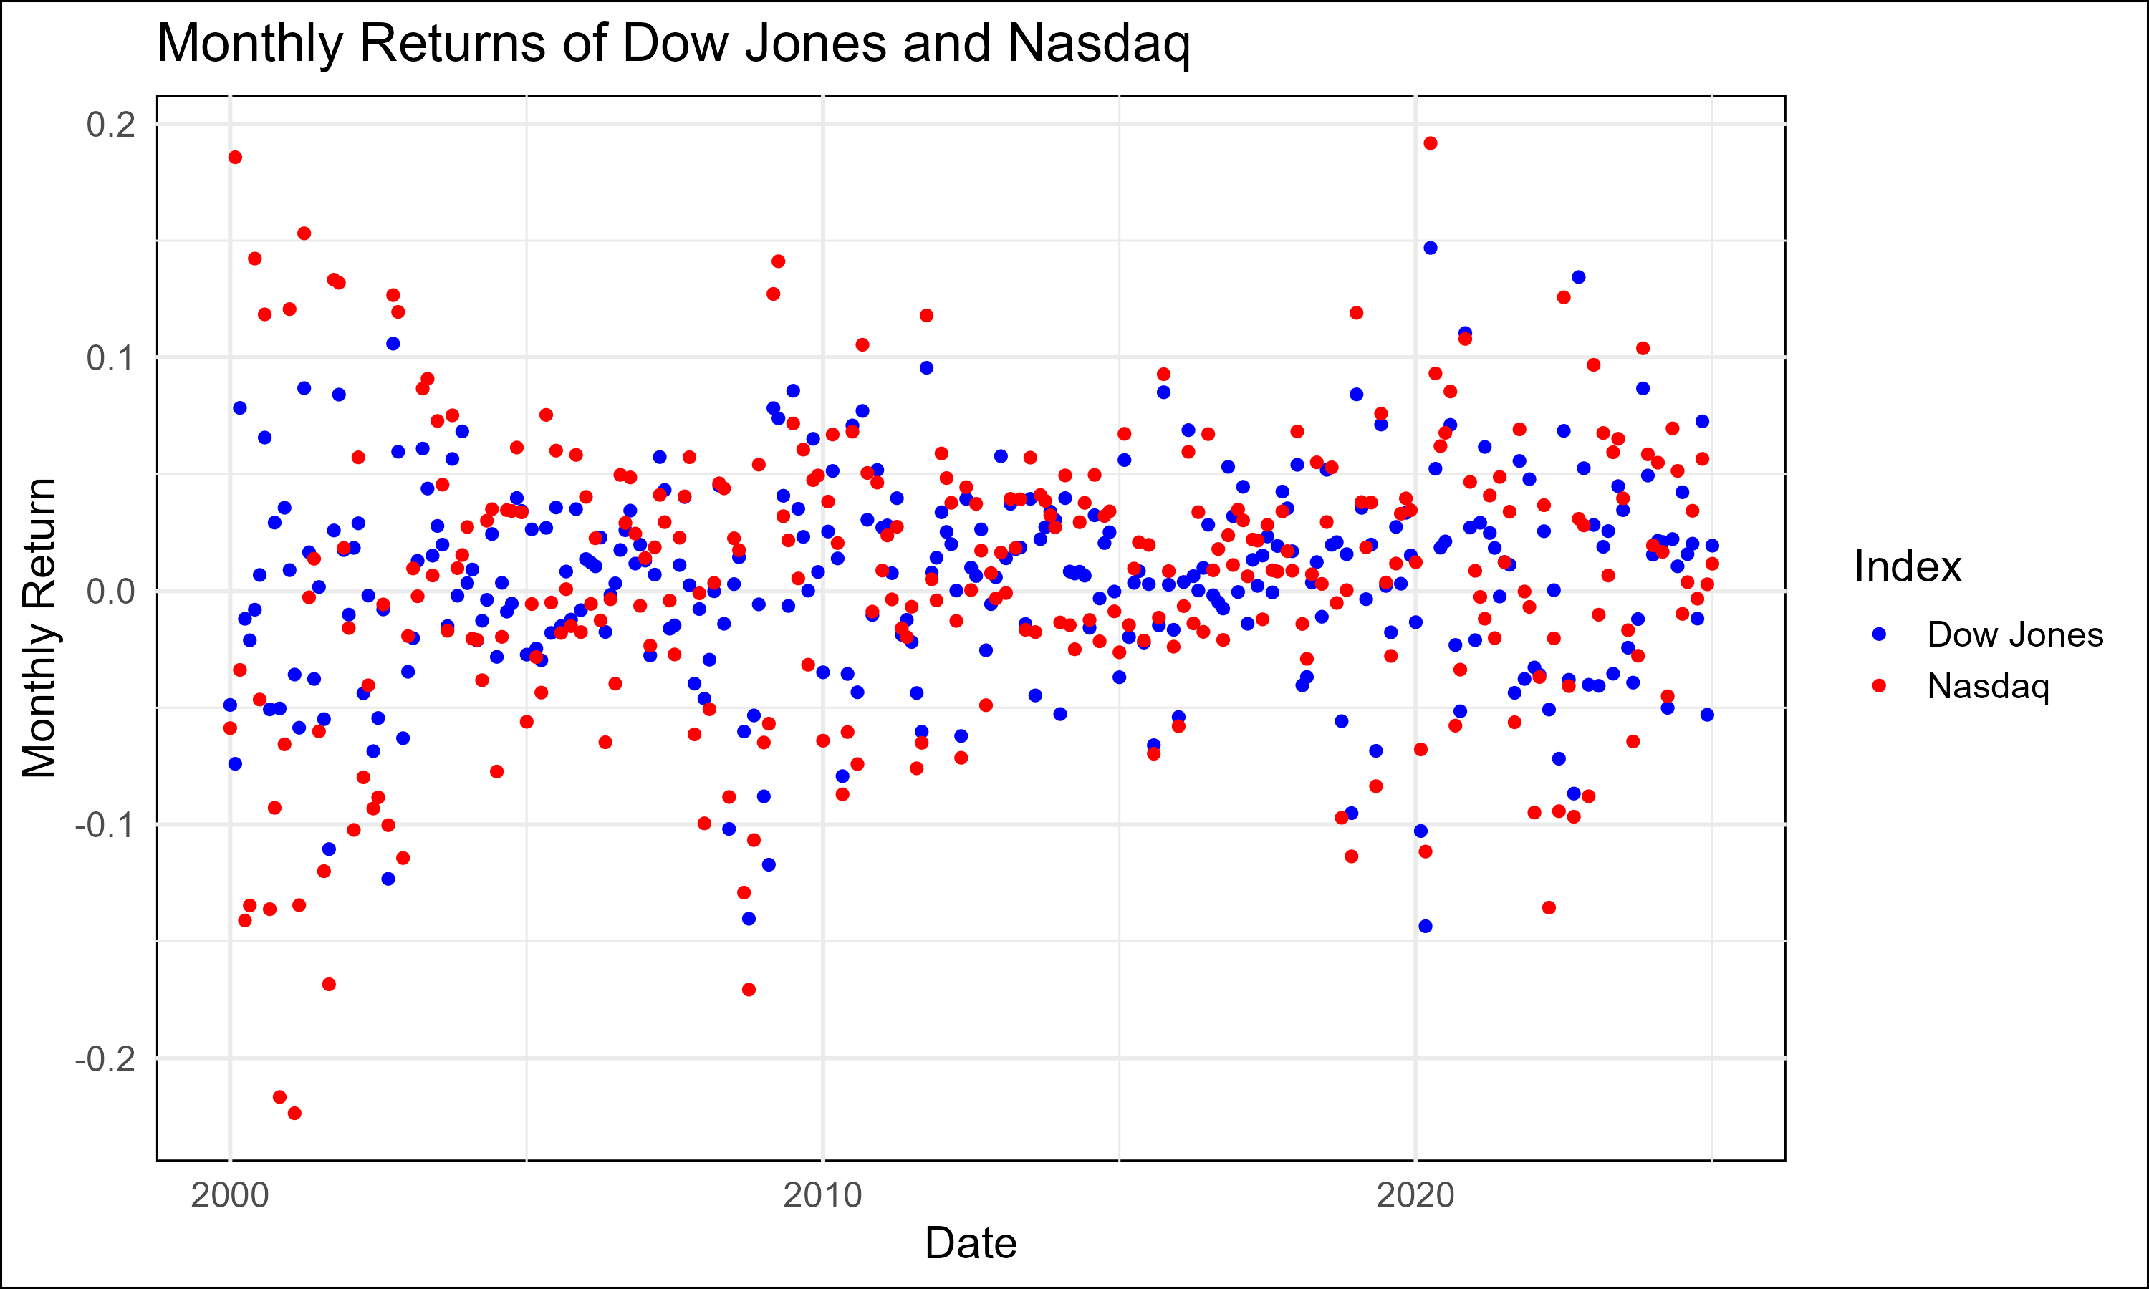

Monthly Returns

This scatter plot visualizes the monthly returns for both indices, providing a more granular view of performance fluctuations.

#### Analysis of Monthly Returns

1. **Higher Volatility in the Nasdaq:**
   * The Nasdaq’s monthly returns exhibit a wider spread compared to the DJIA, confirming its higher short-term volatility.
2. **Seasonality:**
   * Certain months show a tendency for higher returns, which could be linked to seasonal market behavior (e.g., year-end rallies, earnings season effects).
3. **Reversion Opportunities:**
   * The monthly data reveals frequent divergence between the indices, presenting numerous opportunities for implementing a hedged mean-reversion strategy.
4. **Tail Risks:**
   * While most monthly returns cluster near the mean, the presence of outliers in both indices highlights the importance of managing tail risks in the strategy.

### Volatility Analysis

#### Rolling 30-Day Volatility

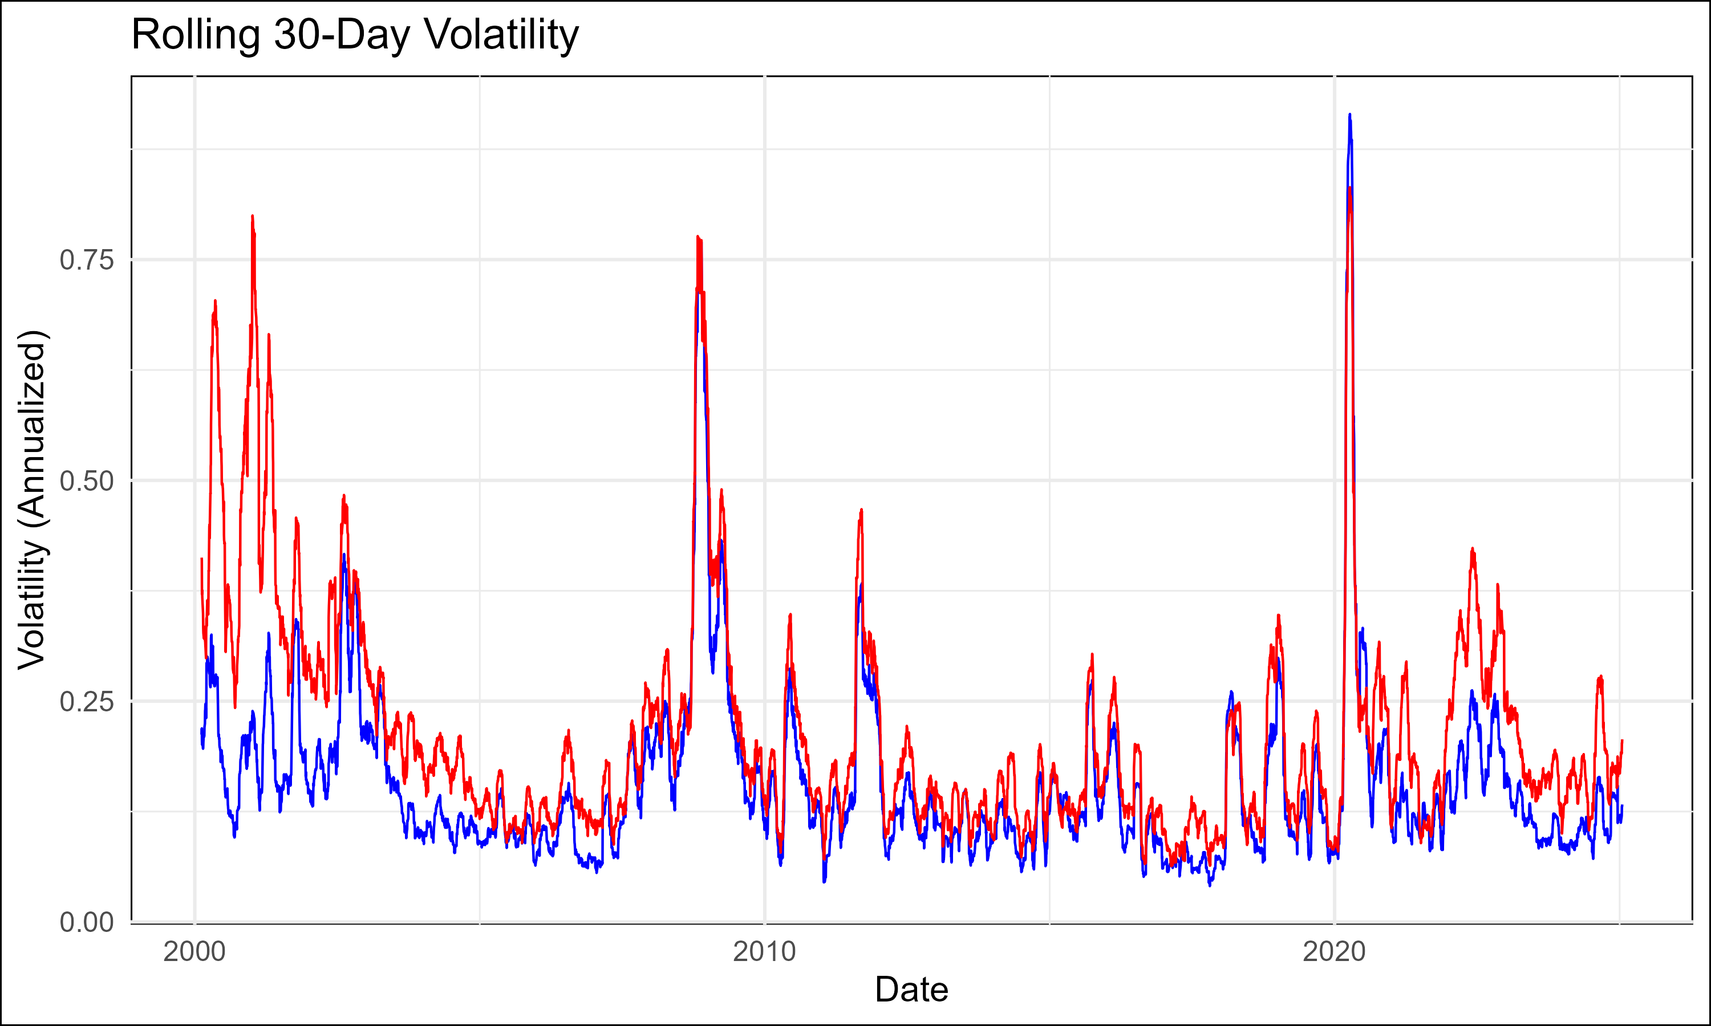

Rolling Volatility

This plot showcases the rolling 30-day annualized volatility of the DJIA (blue line) and Nasdaq (red line). Volatility is a crucial factor in designing a hedged mean-reversion strategy.

#### Analysis of Rolling Volatility

1. **Nasdaq’s Higher Volatility:**
   * The Nasdaq consistently demonstrates higher volatility compared to the DJIA, reflecting its sensitivity to growth-driven narratives and speculative activity.
2. **Volatility Clustering:**
   * Periods of heightened volatility tend to cluster, such as during economic recessions or market crises. These periods often correspond to increased divergence between the indices.
3. **Implications for Strategy Design:**
   * Higher Nasdaq volatility necessitates dynamic position sizing to ensure the hedge ratio remains effective.
   * Volatility spikes provide signals for rebalancing or scaling positions to capitalize on mean-reversion opportunities.
4. **Volatility Decay:**
   * Both indices show periods of declining volatility following spikes, which could indicate mean-reversion in volatility itself.

### Correlation Analysis

#### Rolling 30-Day Correlation between Dow Jones and Nasdaq Returns

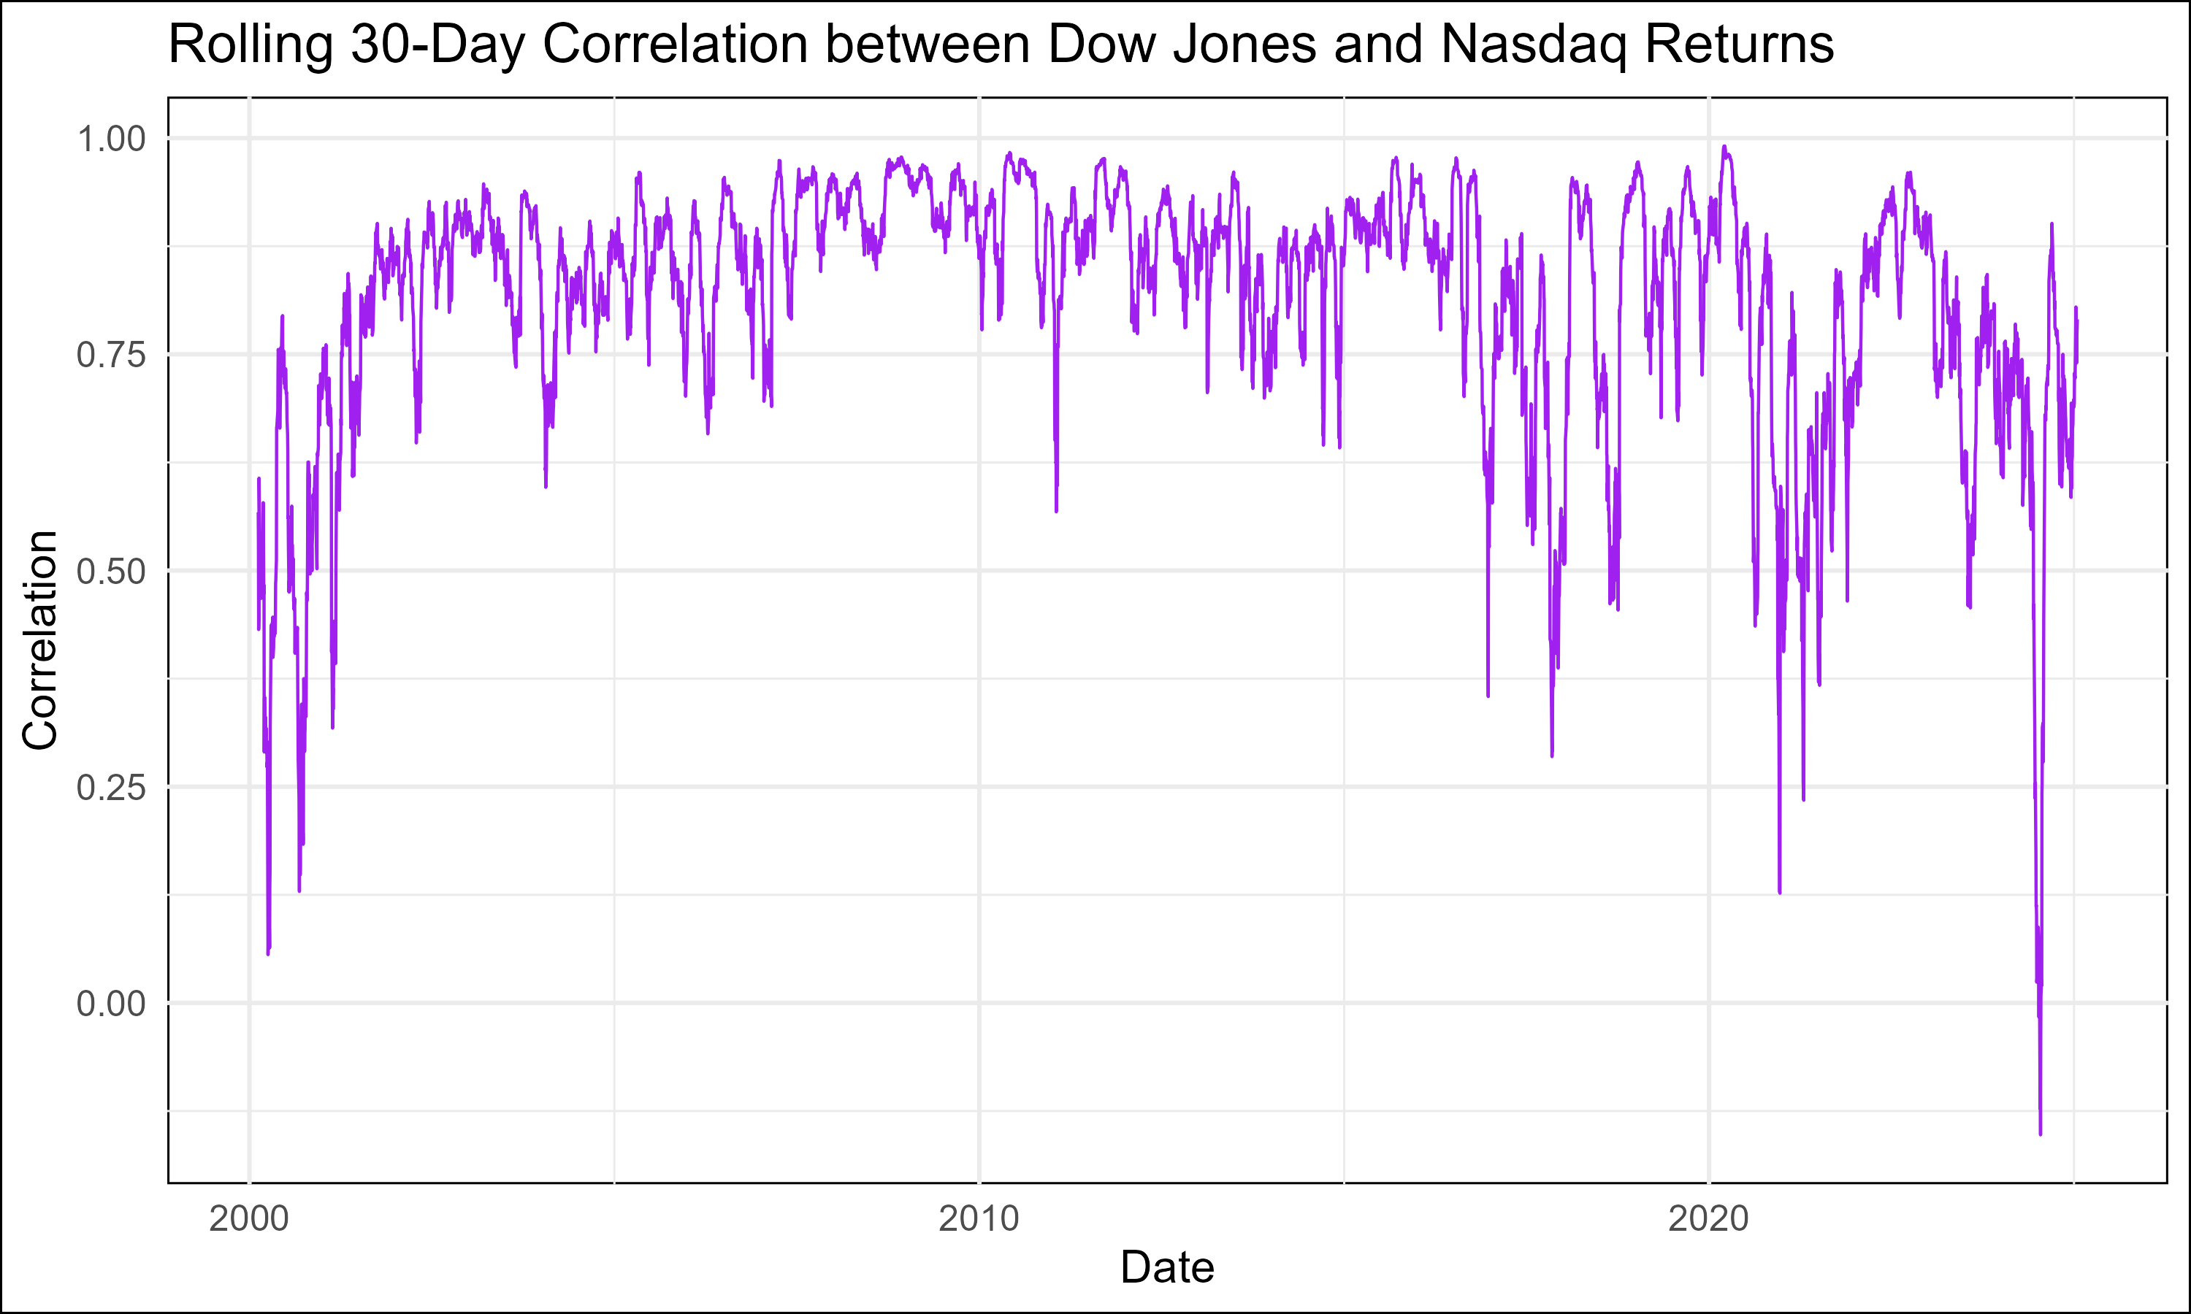

Rolling Correlation

The rolling 30-day correlation plot provides insights into the evolving relationship between the daily returns of the DJIA and Nasdaq over time.

#### Analysis of Rolling Correlation

1. **High Average Correlation:**
   * The average correlation between the two indices is **0.8111483**, suggesting a strong, albeit not perfect, positive relationship.
2. **Periods of Correlation Breakdown:**
   * Temporary declines in correlation occur during periods of market stress (e.g., financial crises), indicating that the indices may diverge significantly in extreme environments.
3. **Hedging Implications:**
   * Correlation breakdowns increase the residual risk of the strategy, necessitating additional safeguards during these periods.
   * Monitoring rolling correlations can provide early warnings of potential divergence risks.
4. **Opportunities from Correlation Extremes:**
   * Periods of unusually high or low correlation can act as signals for adjusting hedge ratios or identifying profitable entry and exit points.

#### Correlation Between Dow Jones and Nasdaq Returns

The overall correlation of **0.8111483** between DJIA and Nasdaq returns reflects a strong historical relationship, driven by the common underlying macroeconomic and market factors influencing both indices.

#### Strategic Implications of Correlation

1. **Strong Foundation for Hedged Mean-Reversion:**
   * A high correlation ensures that divergences are likely temporary, increasing the reliability of reversion opportunities.
2. **Risk Reduction:**
   * The high correlation reduces the residual risk of the hedge, as losses in one leg of the strategy are partially offset by gains in the other.
3. **Tailored Correlation Monitoring:**
   * For enhanced precision, correlations should be monitored on multiple time scales (e.g., intraday, weekly) to capture short-term dynamics alongside long-term trends.

### Cumulative Returns

#### Cumulative Overnight and Intraday Returns for Nasdaq and Dow Jones

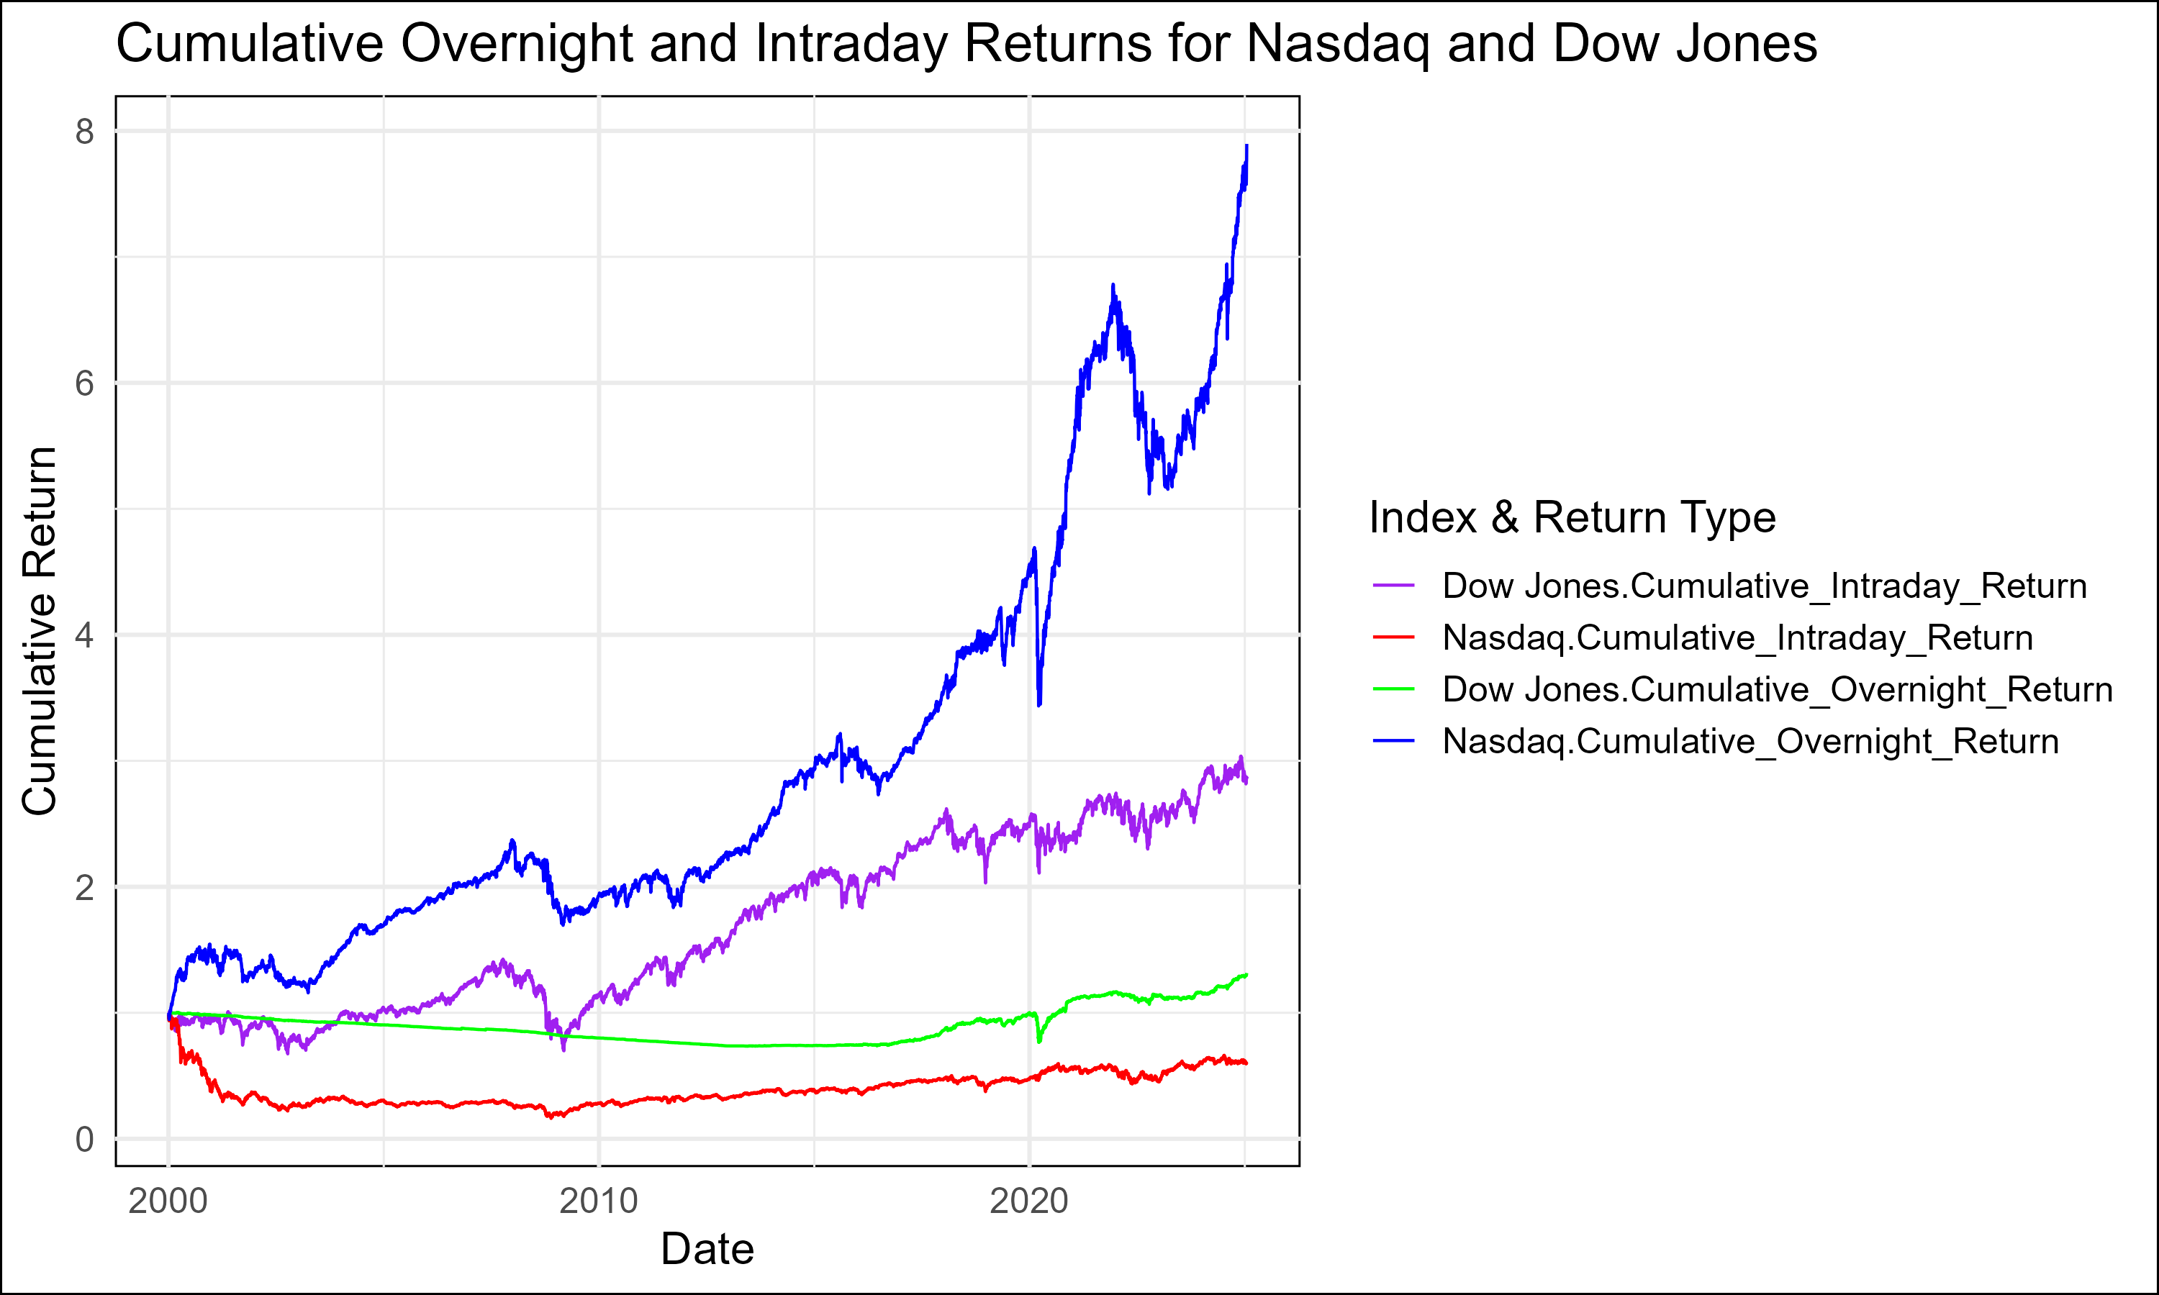

Cumulative Returns

The plot provides a detailed visualization of the cumulative returns for both the Nasdaq Composite Index and the Dow Jones Industrial Average (DJIA), broken down into **overnight** and **intraday** returns. Different colors are used to distinguish between the return types for each index, offering critical insights into how returns are generated across time periods.

#### Analysis of Cumulative Returns

1. **Overnight vs. Intraday Dynamics:**
   * **Nasdaq:**
     + The **cumulative overnight return** (7.896534) far exceeds the **cumulative intraday return** (0.5938398), indicating that a significant portion of Nasdaq’s returns is realized during overnight periods.
     + This trend suggests that Nasdaq’s performance may be heavily influenced by after-hours news, earnings reports, and global macroeconomic factors.
   * **DJIA:**
     + The **cumulative intraday return** (2.873849) dominates the **cumulative overnight return** (1.315637), highlighting that DJIA’s returns are more likely to be generated during regular trading hours.
2. **Return Patterns:**
   * The Nasdaq’s higher overnight returns align with its composition of tech-heavy growth stocks, which are often driven by forward-looking expectations and news catalysts.
   * The DJIA’s intraday dominance reflects the stability and steady price adjustments of its constituent blue-chip companies during trading hours.
3. **Implications for Mean-Reversion Strategy:**
   * Divergences between overnight and intraday cumulative returns can signal opportunities for mean-reversion trades, particularly when one index consistently outpaces the other in a specific period.
   * For example, a significant overnight gain in Nasdaq without a corresponding intraday adjustment in the DJIA might create a short-term divergence to exploit.
4. **Risk Management:**
   * Overnight returns, being less controllable due to after-hours trading dynamics, require careful monitoring. Hedging mechanisms, such as options, can be employed to mitigate overnight gap risks.

### Moving Averages

#### Dow Jones with 50 and 200-Day Moving Averages

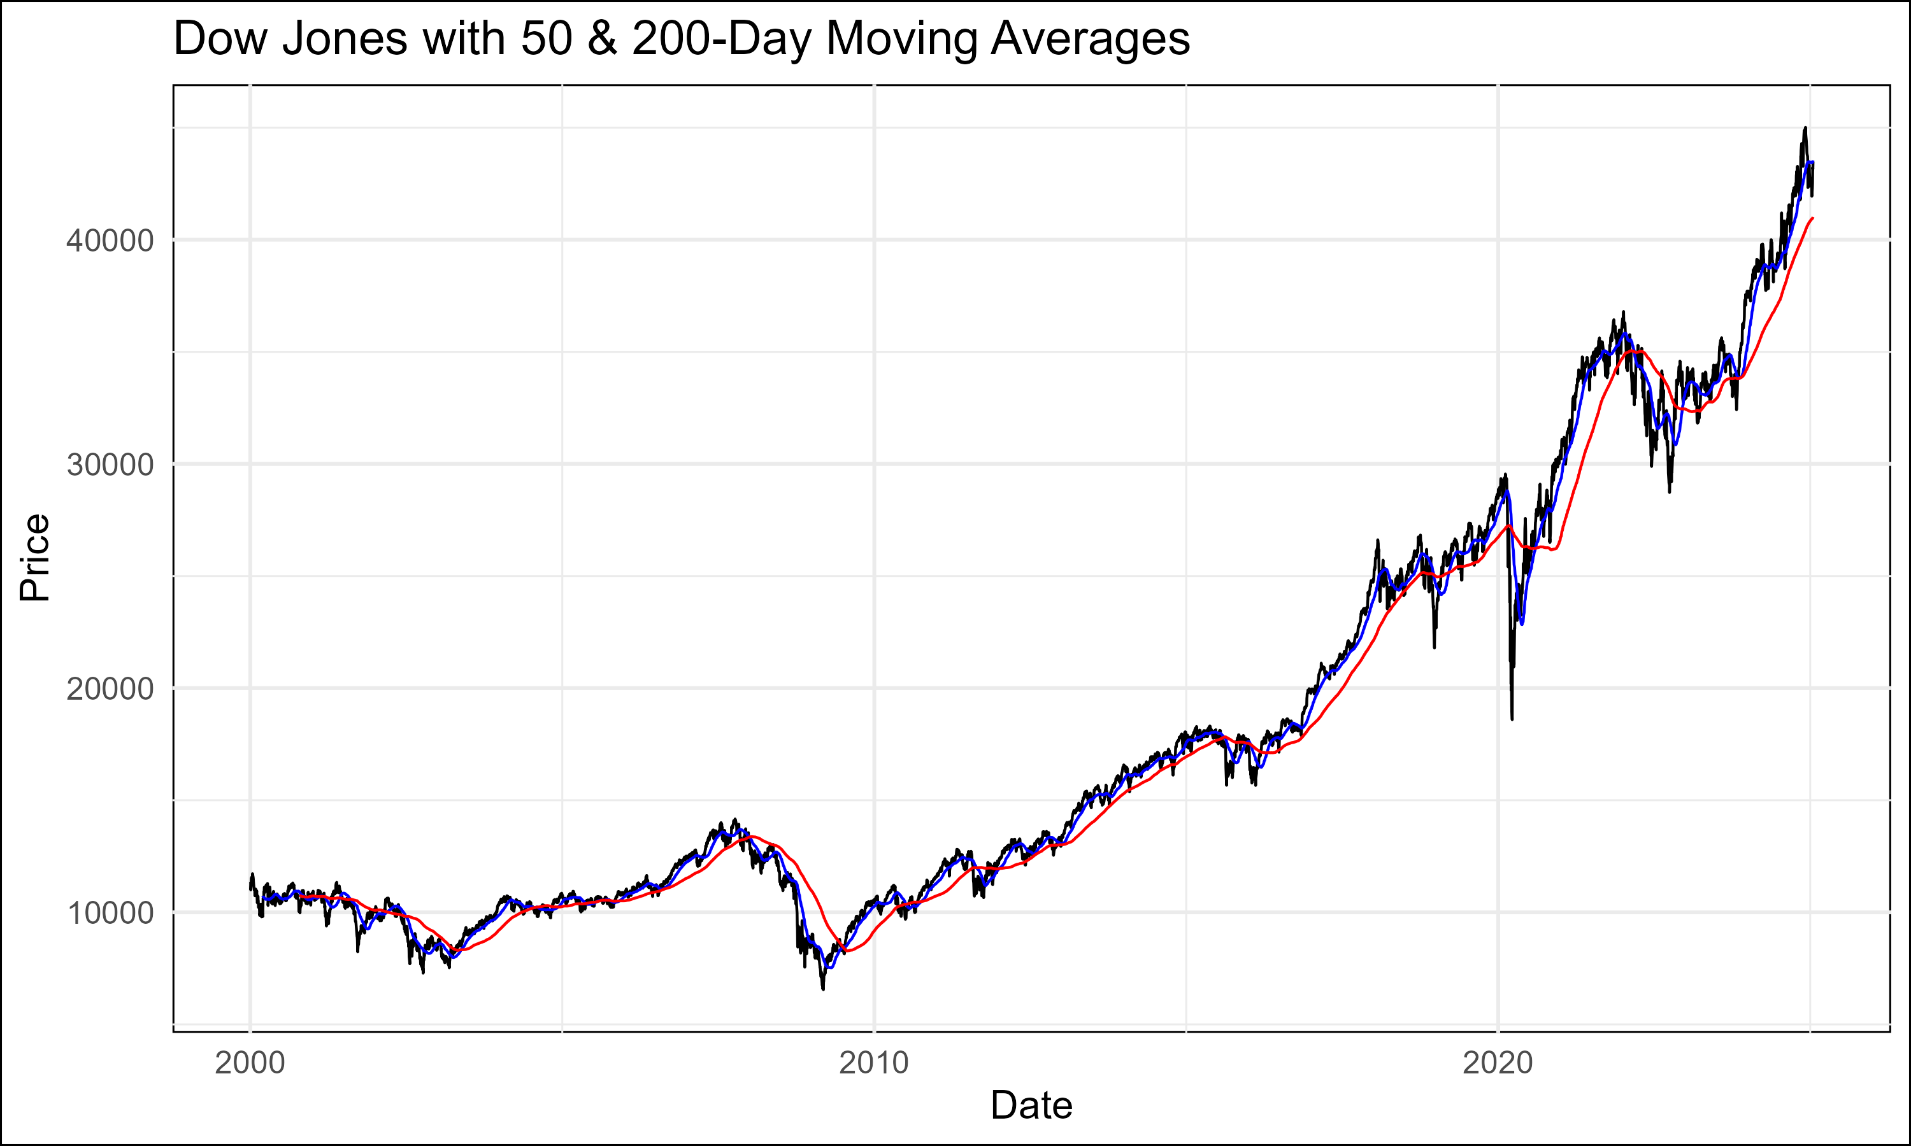

DJIA Moving Averages

This plot illustrates the DJIA’s closing prices overlaid with its 50-day (short-term) and 200-day (long-term) moving averages.

1. **Trend Identification:**
   * The 50-day moving average reflects short-term market trends, while the 200-day moving average captures longer-term momentum.
   * Periods where the 50-day moving average crosses above the 200-day moving average (a “golden cross”) indicate bullish momentum, while the reverse (a “death cross”) signals bearish momentum.
2. **Volatility Analysis:**
   * The relative distance between the moving averages can serve as a proxy for market volatility, with wider gaps indicating strong trends and narrow gaps suggesting consolidation periods.
3. **Implications for Strategy:**
   * Moving averages provide dynamic support and resistance levels, which can help refine entry and exit points in the hedged mean-reversion strategy.

#### Nasdaq with 50 and 200-Day Moving Averages

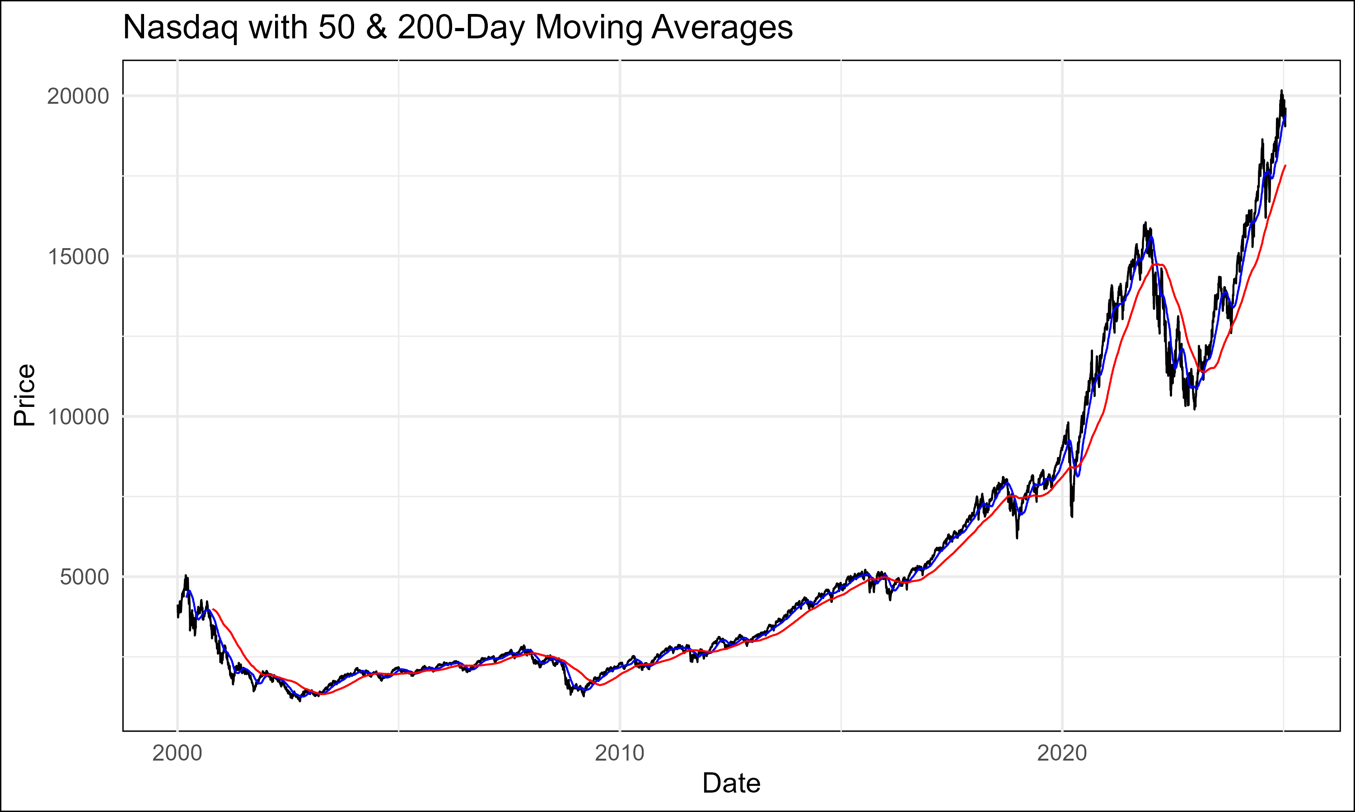

Nasdaq Moving Averages

Similar to the DJIA, this plot shows the Nasdaq’s closing prices with its 50-day and 200-day moving averages.

1. **Higher Sensitivity to Trends:**
   * The Nasdaq’s 50-day moving average exhibits more frequent and larger deviations from the 200-day moving average, reflecting its higher volatility.
2. **Trading Signals:**
   * The more frequent occurrence of golden and death crosses compared to the DJIA presents additional trading signals, particularly in periods of heightened market activity.
3. **Application to Hedged Strategy:**
   * The faster-moving trends in Nasdaq relative to the DJIA create opportunities to capture temporary divergences, which can be exploited through dynamic rebalancing.

### Heatmap of Returns Correlations

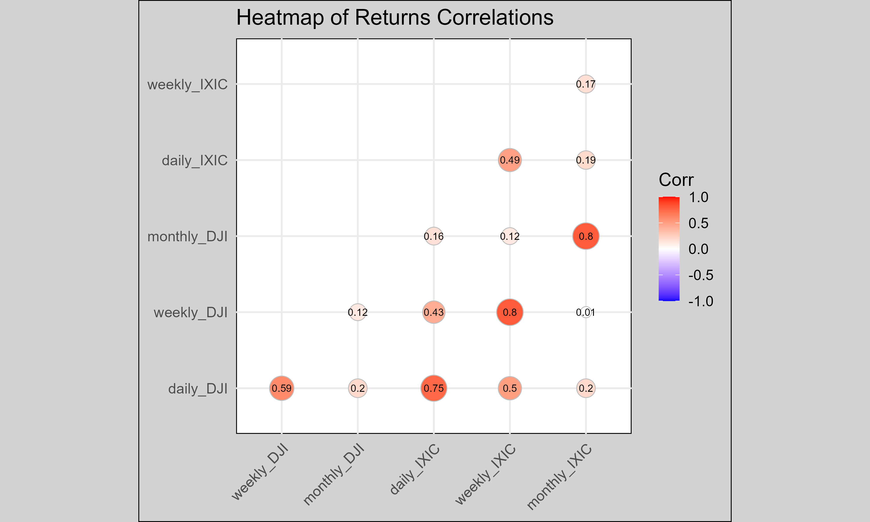

Heatmap of Returns Correlations

This heatmap visualizes the correlations between the returns of the DJIA and Nasdaq across multiple time horizons (daily, weekly, monthly).

#### Analysis of Heatmap

1. **High Overall Correlation:**
   * Strong positive correlations are evident across all time periods, reaffirming the relationship between the two indices.
   * For instance, daily and weekly correlations approach near-perfect levels, supporting the premise of leveraging mean-reversion opportunities.
2. **Timeframe Insights:**
   * **Daily Correlations:**
     + High daily correlations (~0.8) indicate that short-term movements in one index are reliably mirrored by the other.
   * **Monthly Correlations:**
     + While still strong, monthly correlations exhibit slightly more variability, suggesting that long-term factors (e.g., sectoral shifts, macroeconomic divergence) can influence the indices differently.
3. **Strategic Implications:**
   * The consistency of high correlations strengthens the hedged mean-reversion thesis, as significant deviations are likely to revert over time.
   * Monitoring correlations across timeframes provides a robust framework for adjusting hedge ratios dynamically.
4. **Tail Events:**
   * Periods of reduced correlation, often during extreme market conditions, highlight potential risks to the strategy. These instances require increased vigilance and possibly tighter risk controls.

### Summary and Strategic Insights

1. **Cumulative Returns:**
   * The divergence in overnight and intraday returns between the DJIA and Nasdaq reflects structural differences in their compositions, creating actionable opportunities for hedged mean-reversion trades.
2. **Moving Averages:**
   * Dynamic support and resistance levels derived from moving averages enhance the precision of trade execution and risk management.
3. **Correlation Analysis:**
   * High and consistent correlations reinforce the foundation of the mean-reversion strategy, with temporary deviations offering profitable entry and exit points.
   * Heatmaps and rolling correlations should be closely monitored to detect potential structural shifts in the relationship between the indices.

#### Correlation Matrices by Sentiment Zone

Correlation matrices by sentiment zone provide a granular view of the relationships between the Nasdaq Composite Index and the Dow Jones Industrial Average (DJIA) under varying market sentiment conditions. These matrices reveal how the strength and direction of correlations shift across different risk environments, as defined by sentiment zones derived from VIX (Volatility Index) scores.

##### Very High Sentiment

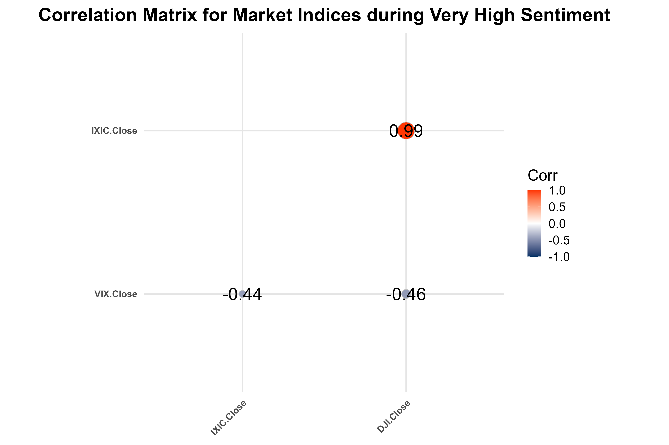

Correlation Matrix Very High

1. **Characteristics:**
   * During periods of very high sentiment (extreme optimism), correlations between the Nasdaq and DJIA often decrease compared to other zones.
   * The divergence stems from sector-specific exuberance in the Nasdaq (e.g., technology-driven rallies), which may not be mirrored by the DJIA’s more diversified composition.
2. **Strategic Implications:**
   * Lower correlations during this zone provide significant opportunities for mean-reversion trades as divergences are more pronounced.
   * However, risk management becomes critical due to higher volatility associated with extreme sentiment.

##### High Sentiment

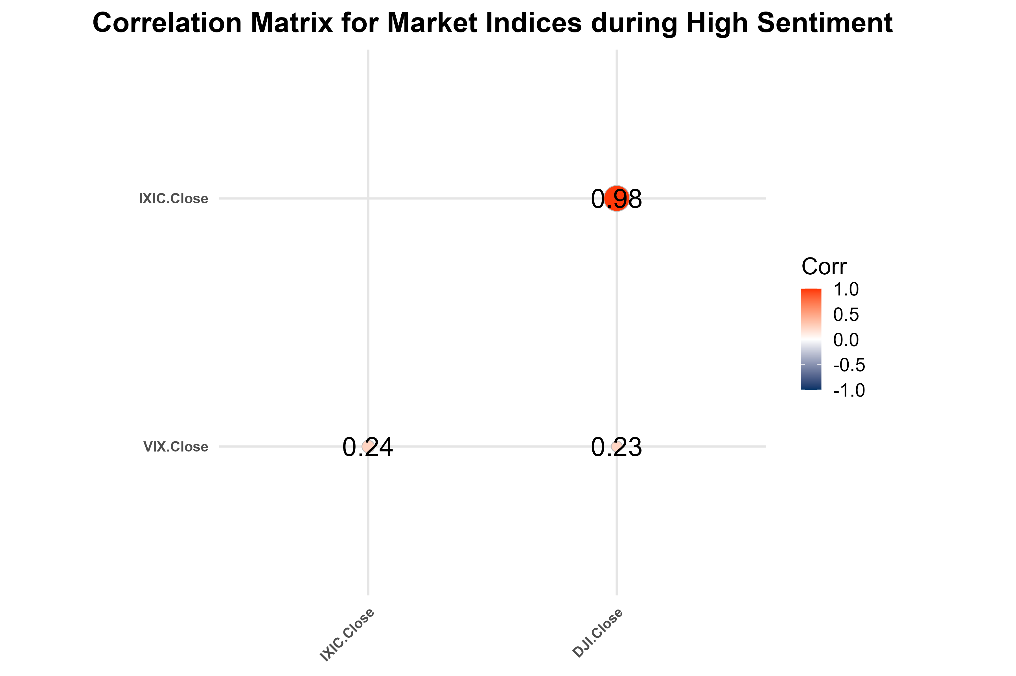

Correlation Matrix High

1. **Characteristics:**
   * In high sentiment environments, correlations strengthen relative to the very high sentiment zone, reflecting a broader market-wide rally.
   * Both indices often move in tandem as investors display a uniform appetite for risk.
2. **Strategic Implications:**
   * Correlation convergence provides more stable hedging opportunities, reducing the residual risk of the strategy.
   * Trades initiated during this zone tend to exhibit lower reversion speed, necessitating longer holding periods.

##### Neutral Sentiment

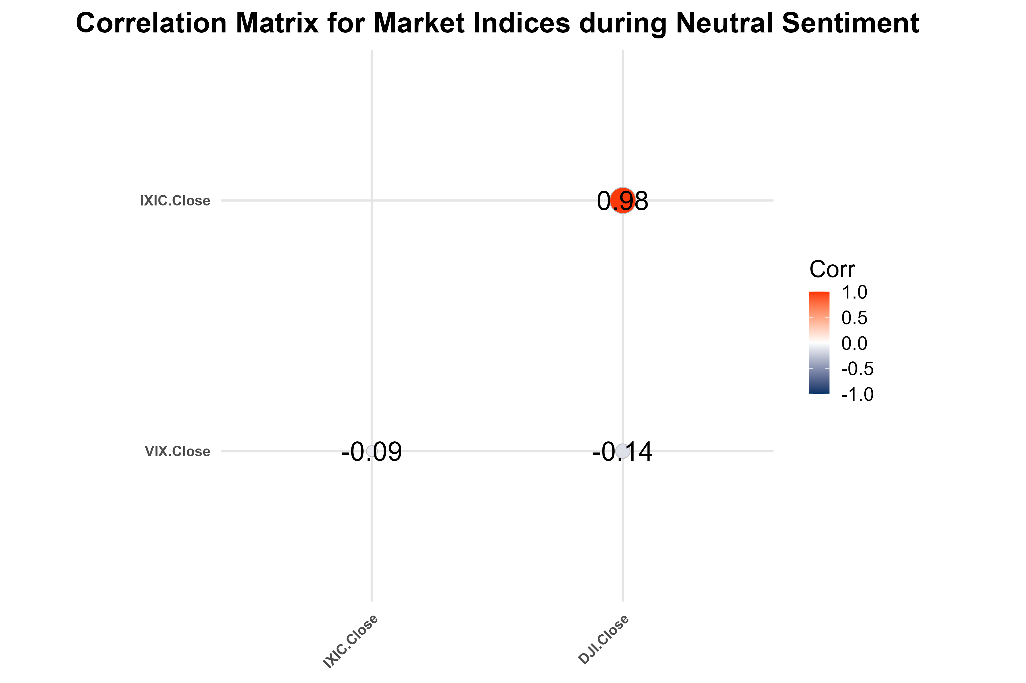

Correlation Matrix Neutral

1. **Characteristics:**
   * Correlations are at their peak in neutral sentiment zones, indicating synchronized movements between the indices.
   * This environment reflects market equilibrium, where neither excessive optimism nor pessimism drives the indices.
2. **Strategic Implications:**
   * Opportunities for mean-reversion trades are limited due to the high alignment in index behavior.
   * The strategy may require narrower thresholds for detecting divergence, with faster execution to capture smaller mean-reversion opportunities.

##### Low Sentiment

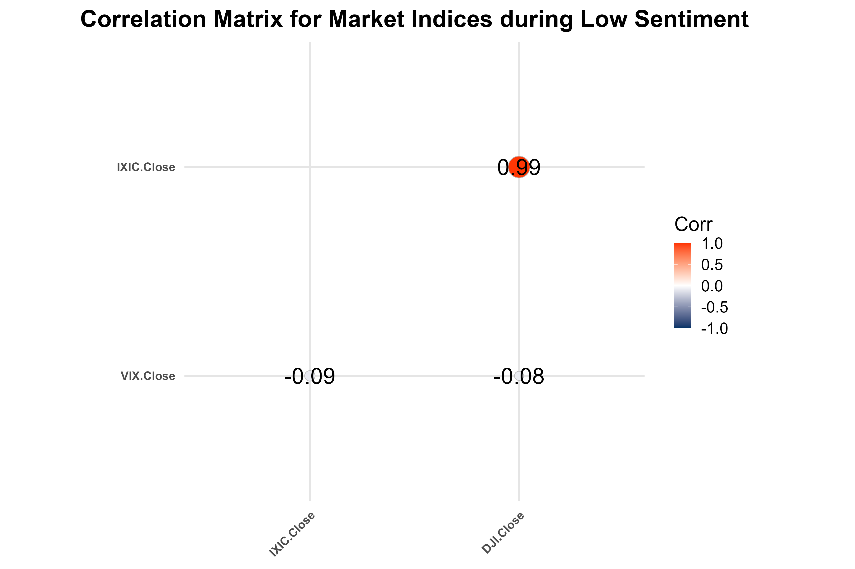

Correlation Matrix Low

1. **Characteristics:**
   * Correlations begin to weaken as sentiment shifts to low, with market participants favoring risk-off assets.
   * The DJIA, composed of stable blue-chip companies, tends to outperform the more volatile Nasdaq during these periods.
2. **Strategic Implications:**
   * Mean-reversion trades should focus on short Nasdaq/long DJIA positions to capitalize on relative stability.
   * Monitoring rolling correlations becomes critical to detect further breakdowns in relationships.

##### Very Low Sentiment

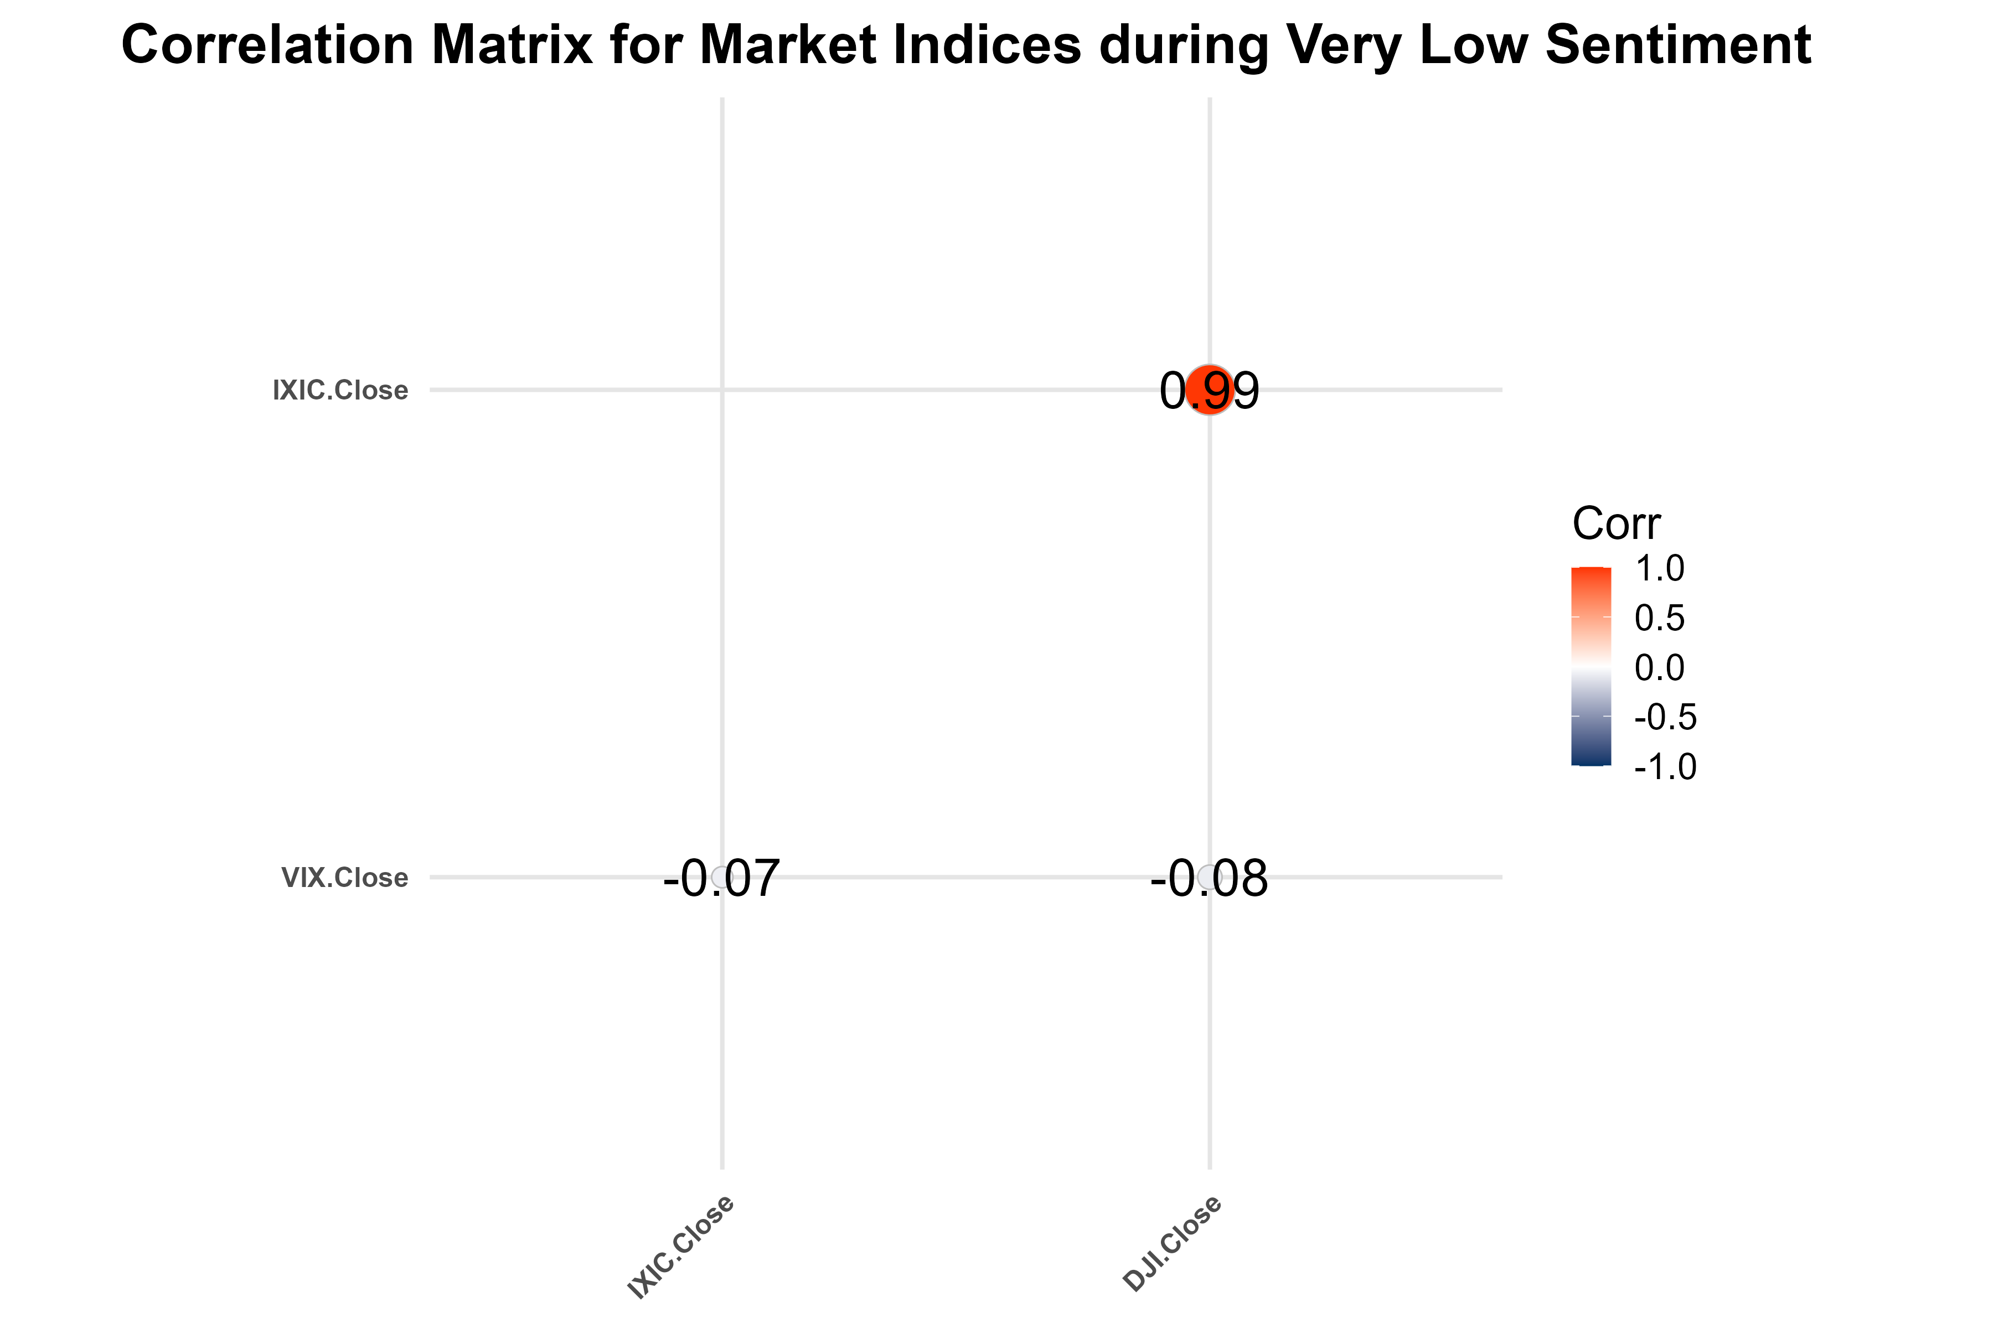

Correlation Matrix Very Low

1. **Characteristics:**
   * During very low sentiment (extreme pessimism), correlations often collapse as panic-driven sell-offs disproportionately impact riskier assets like those in the Nasdaq.
   * This environment creates significant divergence opportunities, but also carries higher tail risks.
2. **Strategic Implications:**
   * Hedged mean-reversion strategies must be executed cautiously, with tighter controls on position sizing.
   * Protective measures, such as stop-loss levels or options hedging, can mitigate risks from sustained divergence.

### Seasonal Analysis

Seasonal patterns in returns provide valuable insights for identifying potential biases in market behavior across time periods.

#### Histogram of Monthly Returns for NASDAQ Composite

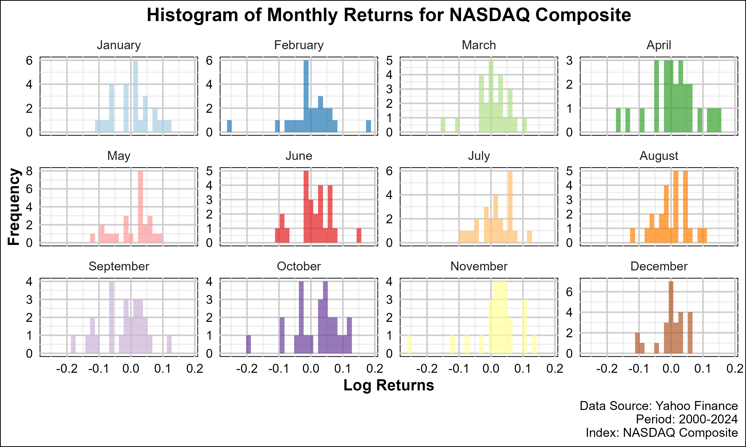

NASDAQ Monthly Returns Histogram

1. **Monthly Distribution:**
   * The histogram reveals varying return distributions across months, highlighting seasonality in the Nasdaq.
   * For instance, months such as January and December often exhibit higher returns, reflecting the “January effect” and year-end rallies.
2. **Strategic Implications:**
   * Seasonal biases can guide adjustments in the hedged strategy, such as increasing exposure during historically strong months.

#### Density Plot of Quarterly Returns for NASDAQ Composite

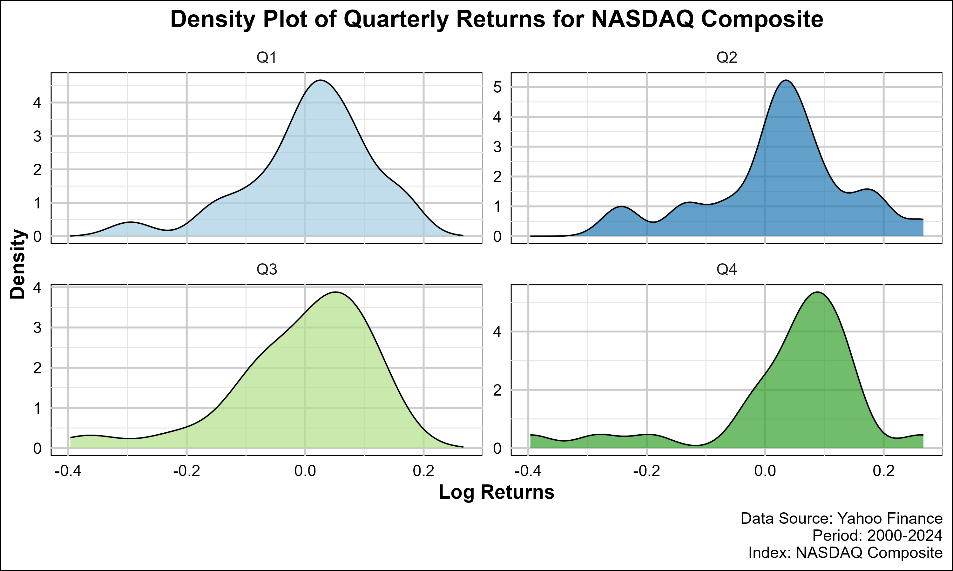

NASDAQ Quarterly Returns Density

1. **Quarterly Variations:**
   * The density plot illustrates the quarterly return distributions, emphasizing periods with higher likelihood of extreme returns.
   * Skewness and kurtosis vary significantly across quarters, reflecting different market dynamics.
2. **Strategic Implications:**
   * Recognizing quarterly patterns helps in timing entry and exit points for the strategy, particularly during earnings seasons.

#### Average Monthly Returns for NASDAQ Composite

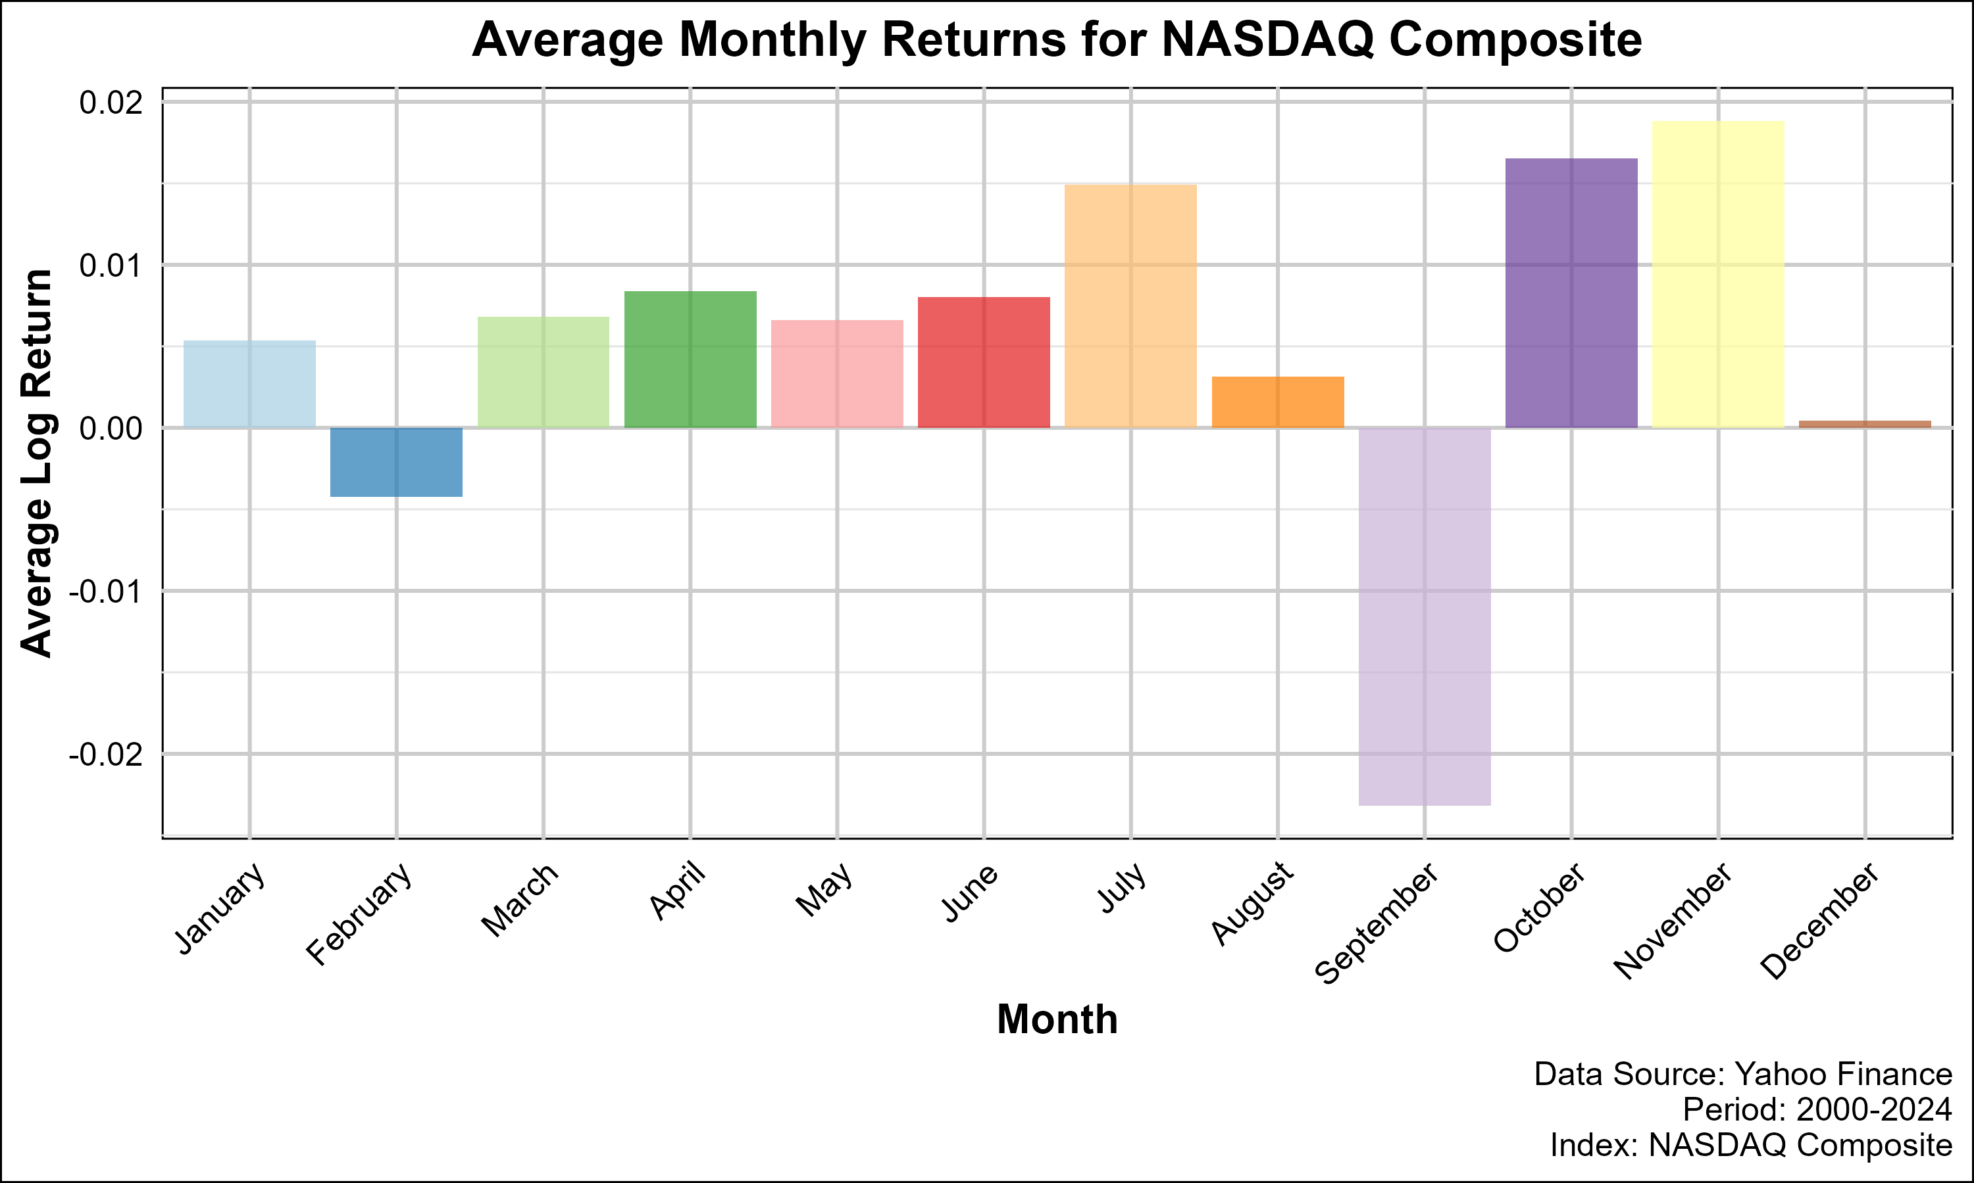

NASDAQ Average Monthly Returns

1. **Insights:**
   * The bar plot indicates that average monthly returns vary, with months like April and November consistently delivering higher returns.
2. **Strategic Implications:**
   * Aligning trades with high-return months enhances the probability of capturing profitable mean-reversion opportunities.

#### Median Monthly Returns for NASDAQ Composite

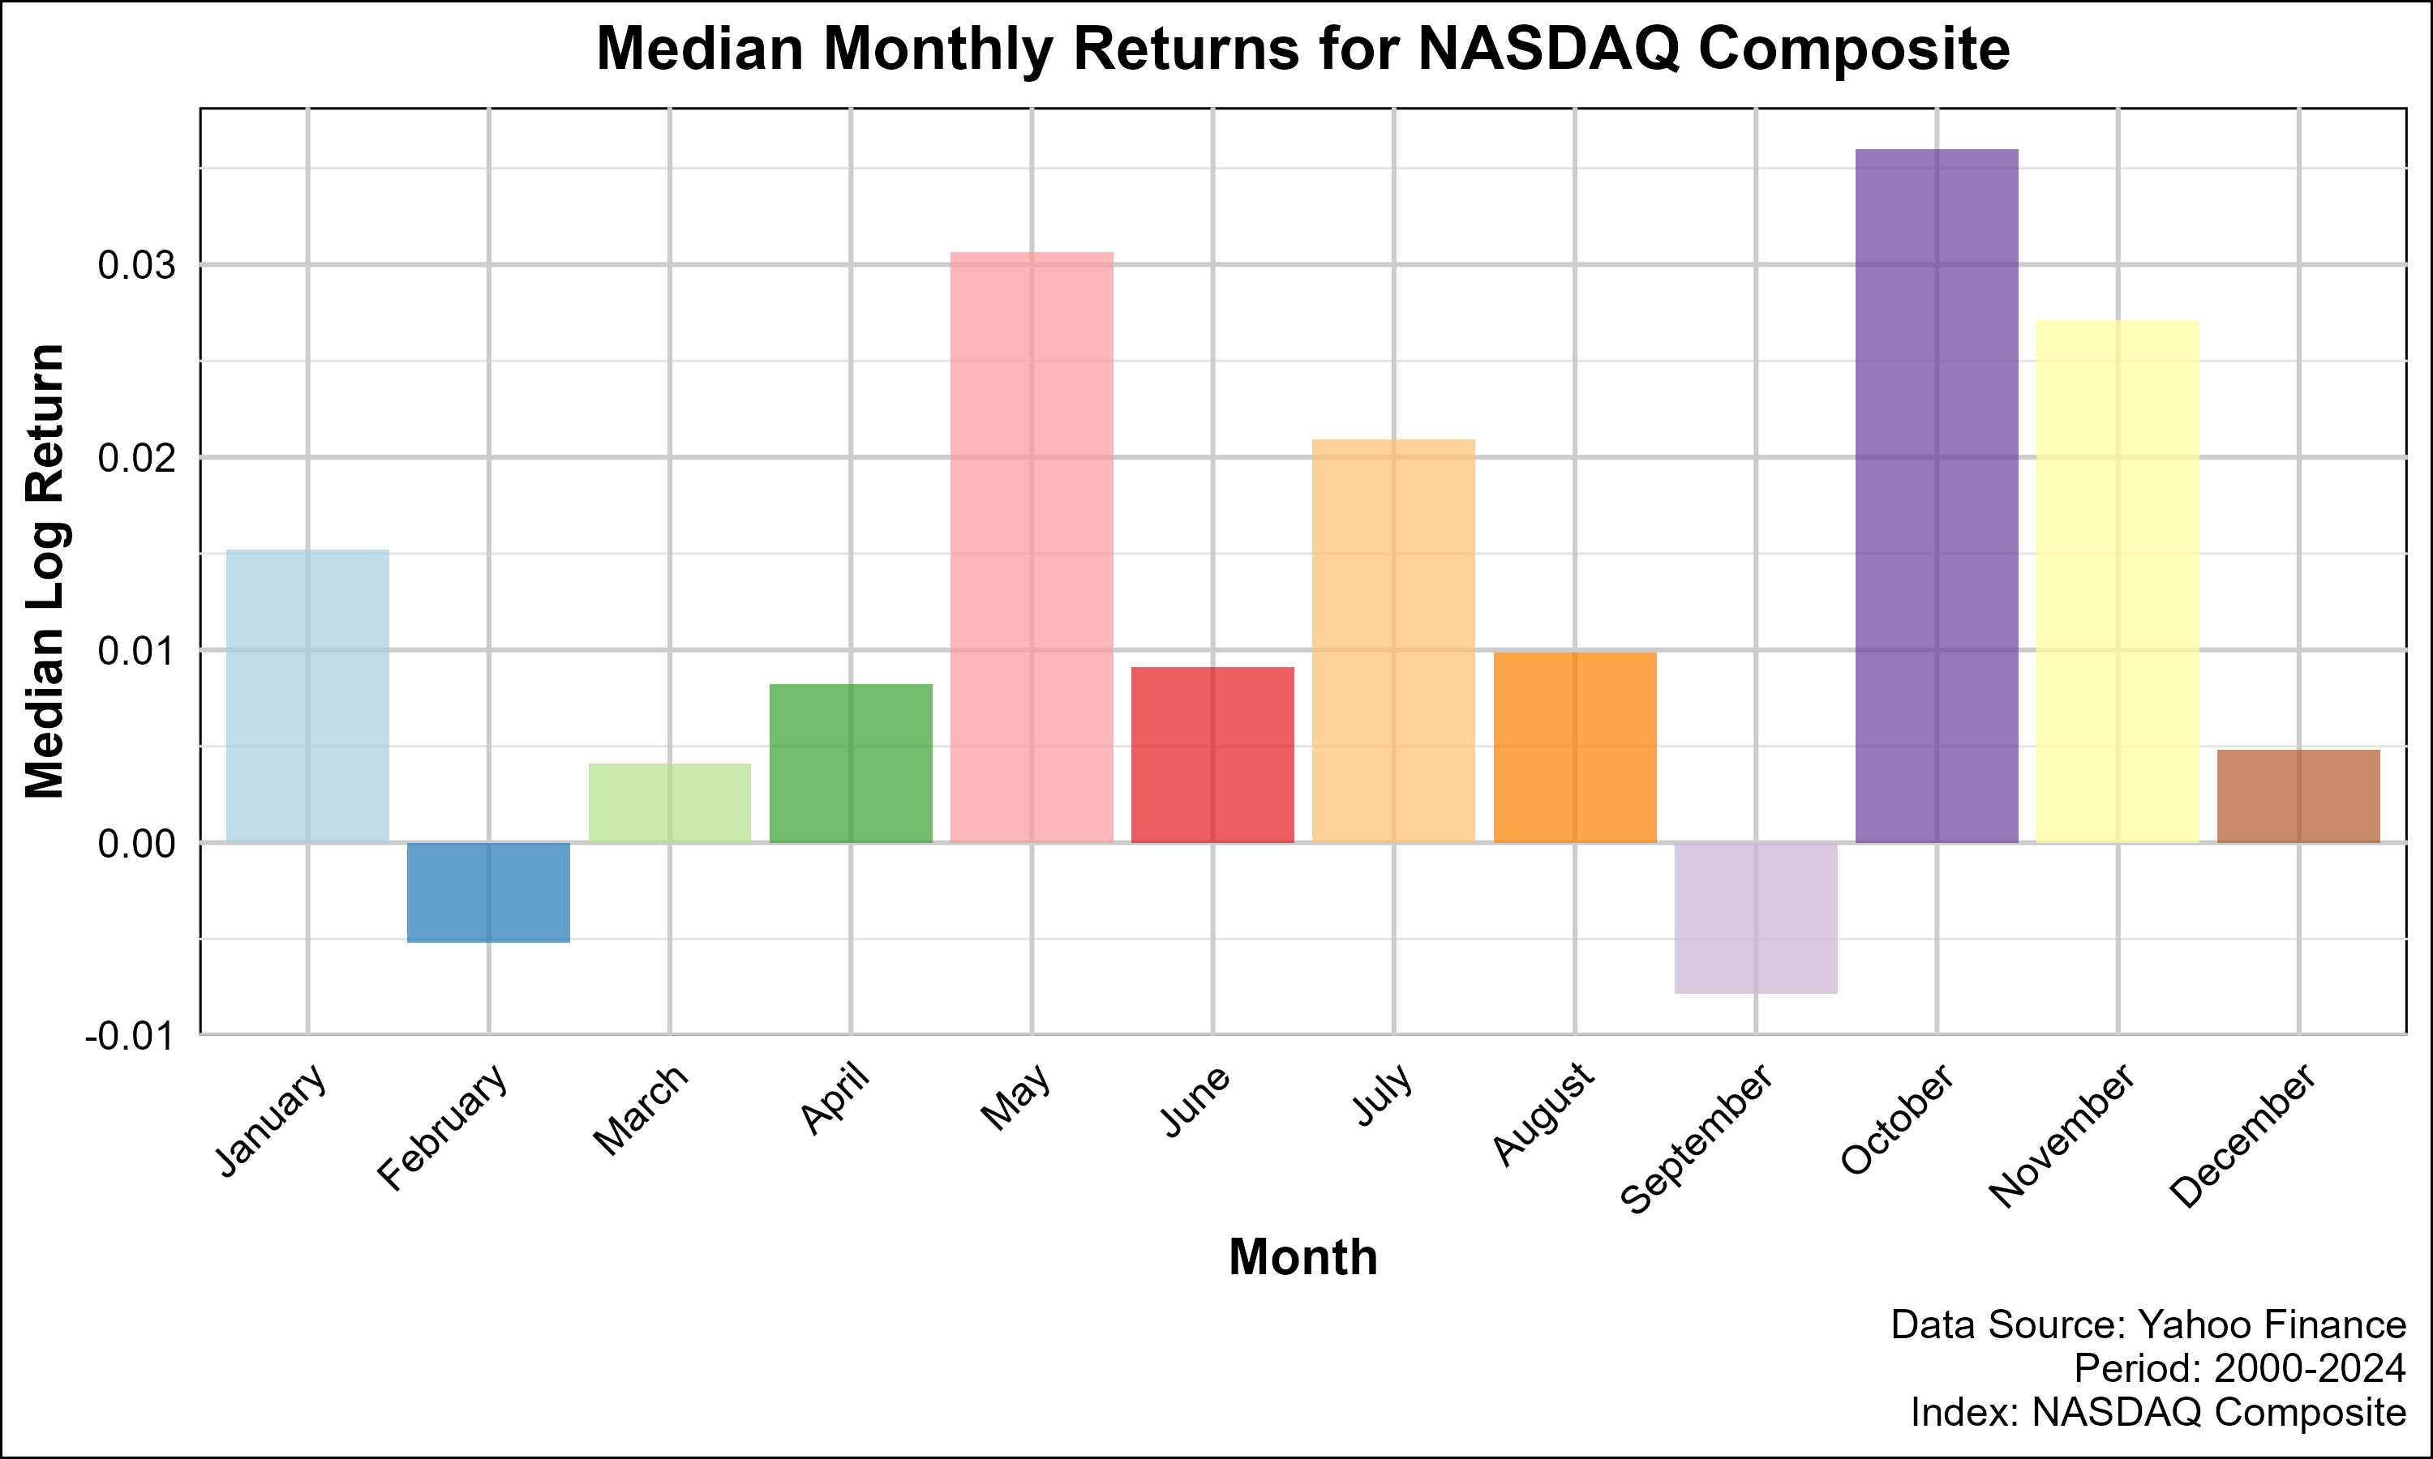

NASDAQ Median Monthly Returns

1. **Comparison with Averages:**
   * Median returns provide a robust measure against outliers, offering a clearer view of typical monthly performance.
2. **Strategic Implications:**
   * Combining median and average return insights refines expectations for divergence magnitude and duration.

#### Histogram of Monthly Returns for Dow Jones Industrial Average

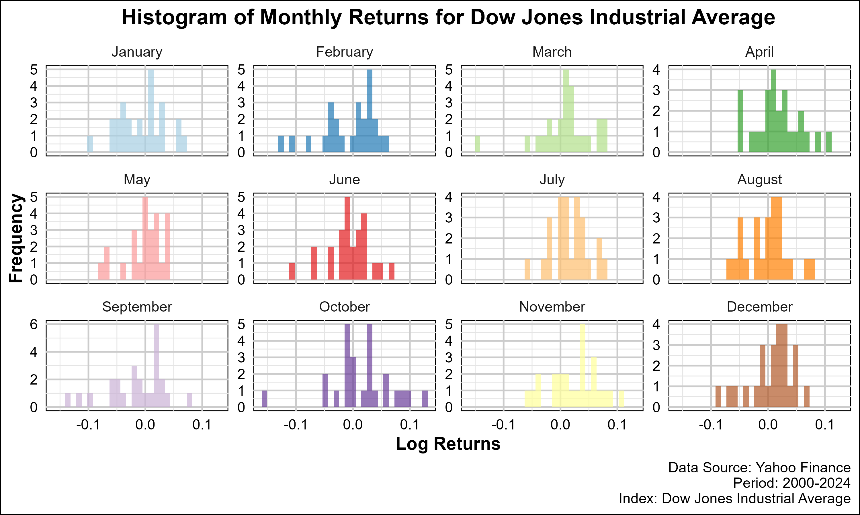

DJIA Monthly Returns Histogram

1. **Monthly Behavior:**
   * The DJIA’s histogram displays narrower monthly return distributions, consistent with its lower volatility.
2. **Strategic Implications:**
   * Divergence thresholds for the DJIA should account for its more predictable monthly performance compared to the Nasdaq.

#### Density Plot of Quarterly Returns for Dow Jones Industrial Average

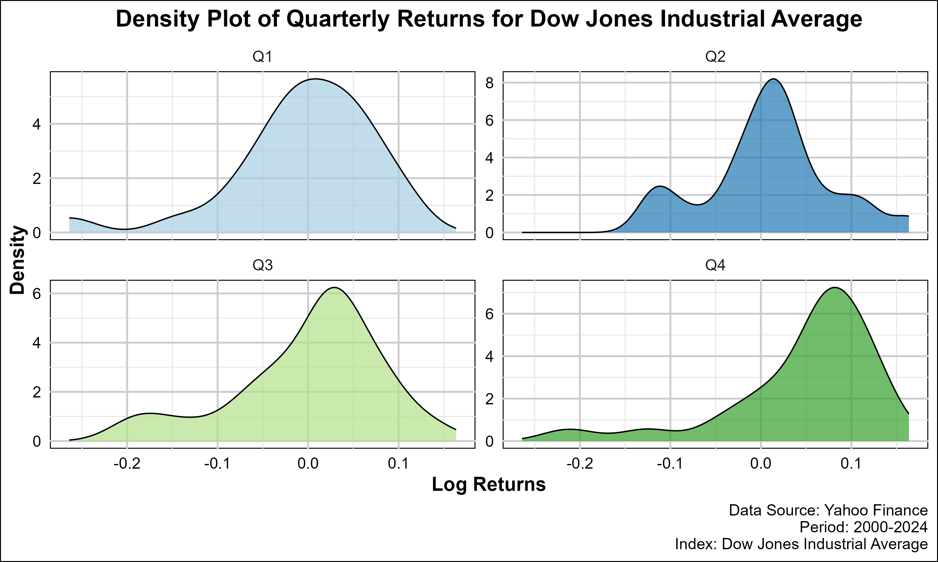

DJIA Quarterly Returns Density

1. **Volatility Clustering:**
   * Quarters associated with economic reports or geopolitical events exhibit higher variability.
2. **Strategic Implications:**
   * Hedged positions should consider quarterly patterns to anticipate periods of increased divergence.

#### Average Monthly Returns for Dow Jones Industrial Average

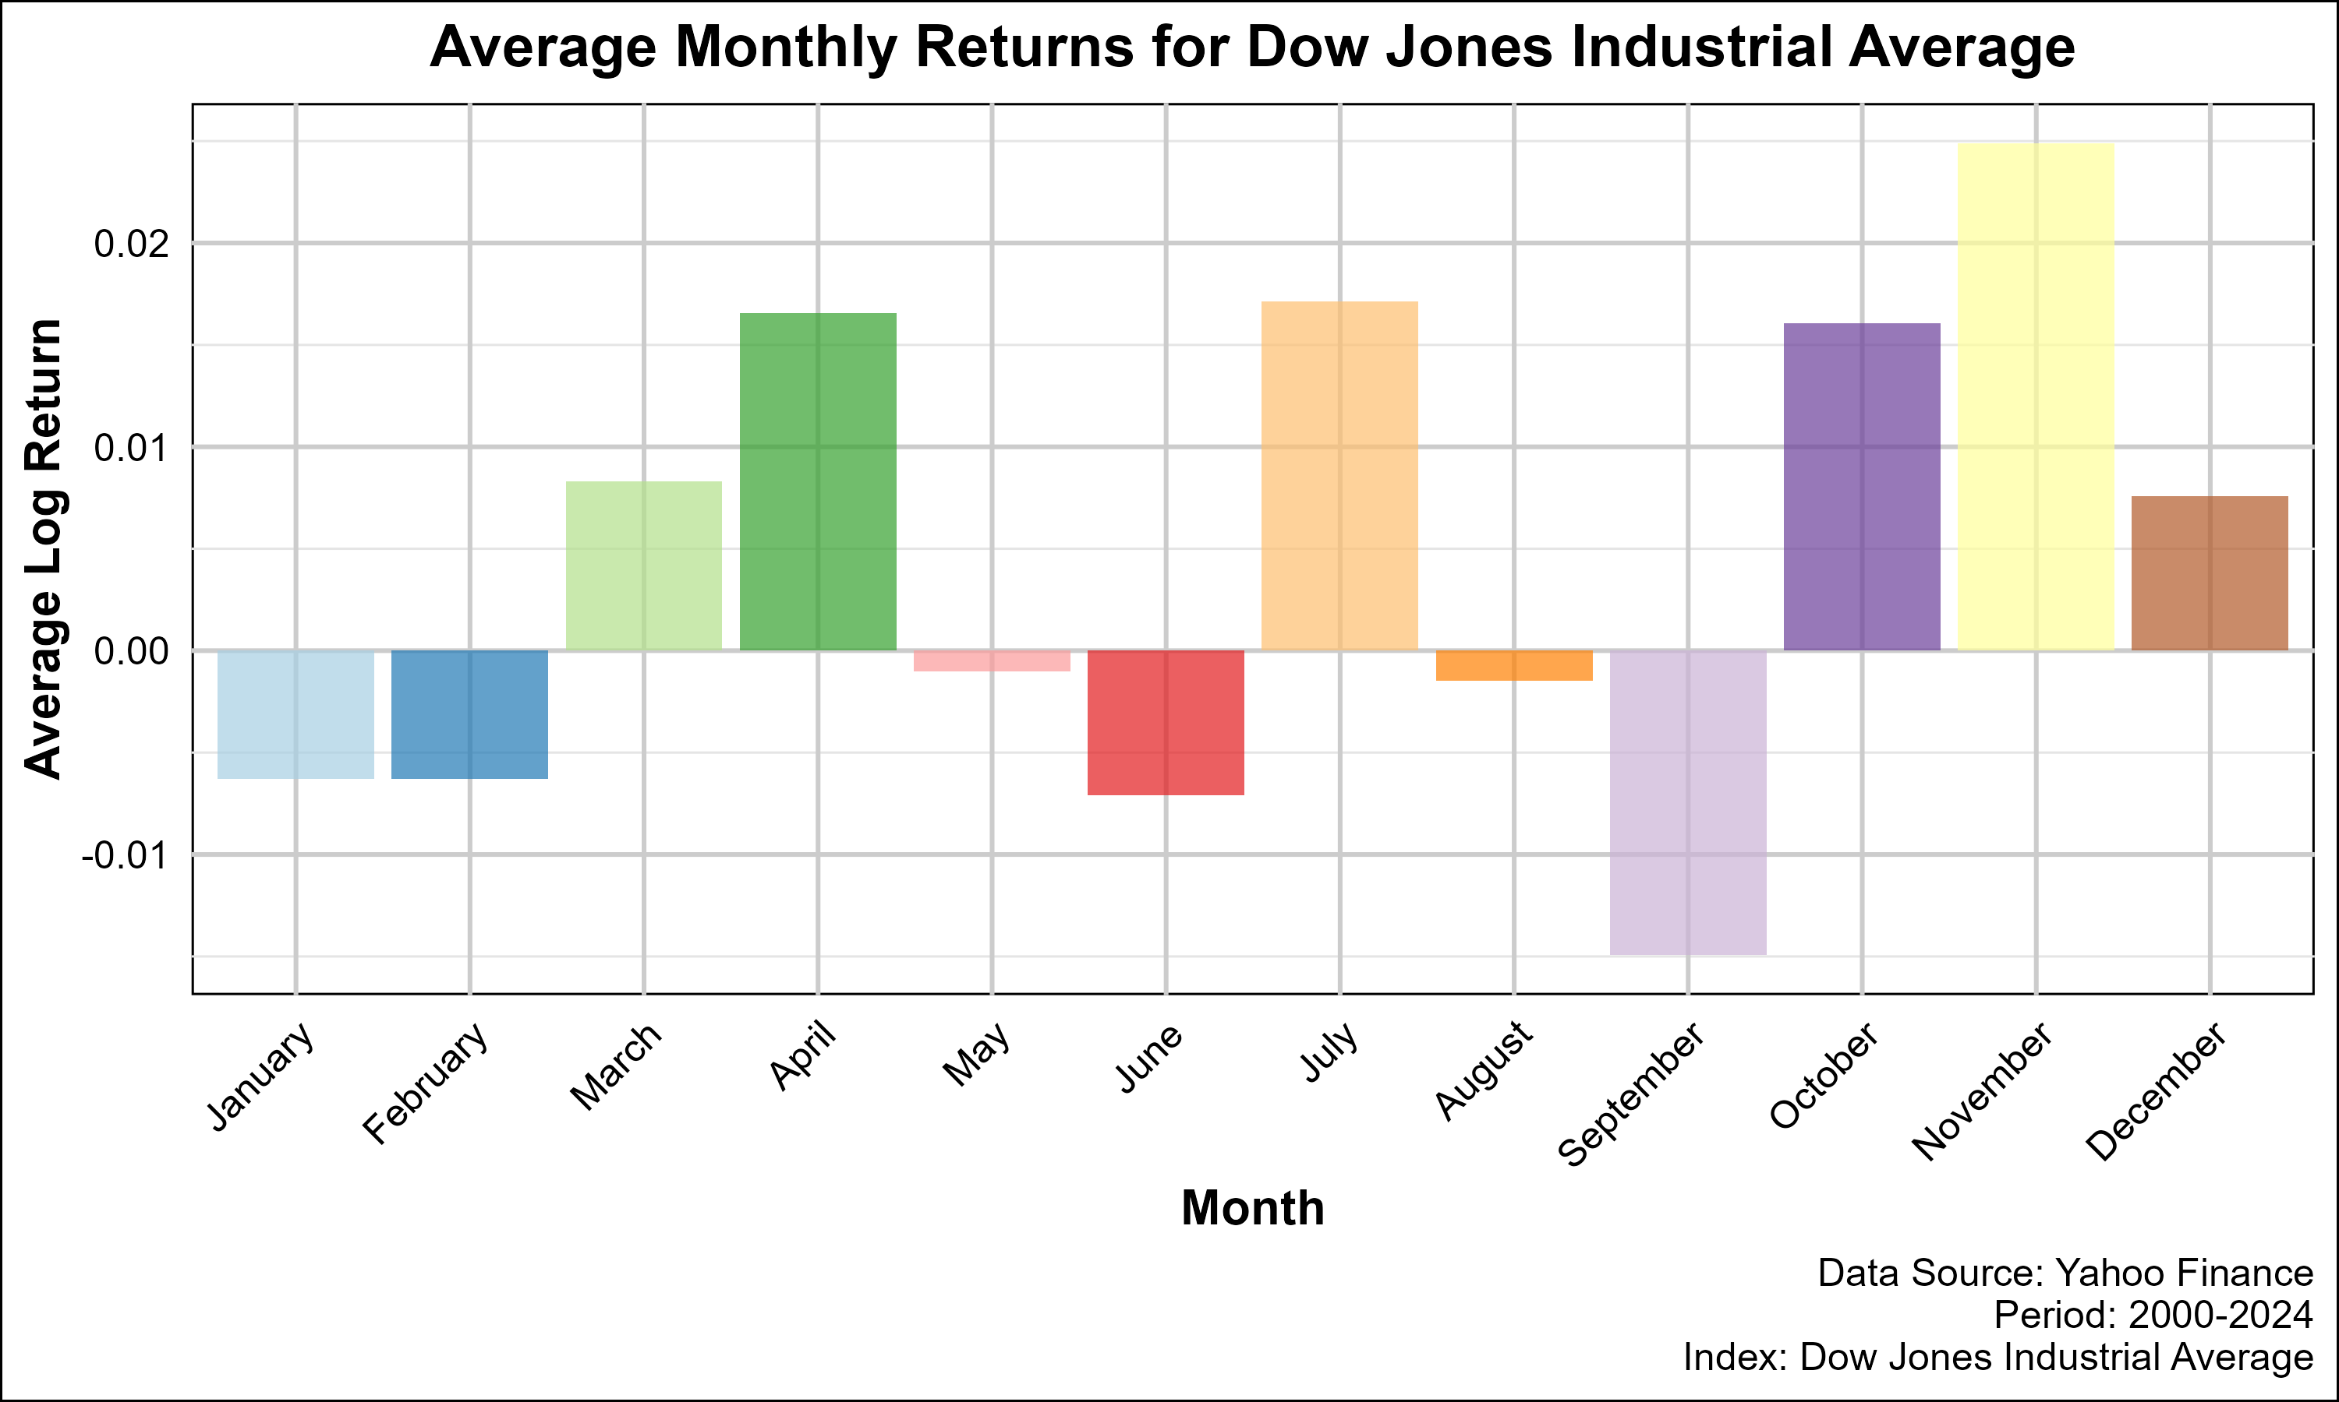

DJIA Average Monthly Returns

1. **Stable Seasonal Trends:**
   * Unlike the Nasdaq, the DJIA exhibits less pronounced seasonal fluctuations, with steady average monthly returns.
2. **Strategic Implications:**
   * The stability in DJIA returns can serve as a counterbalance to the Nasdaq’s volatility, ensuring the hedge remains effective.

#### Median Monthly Returns for Dow Jones Industrial Average

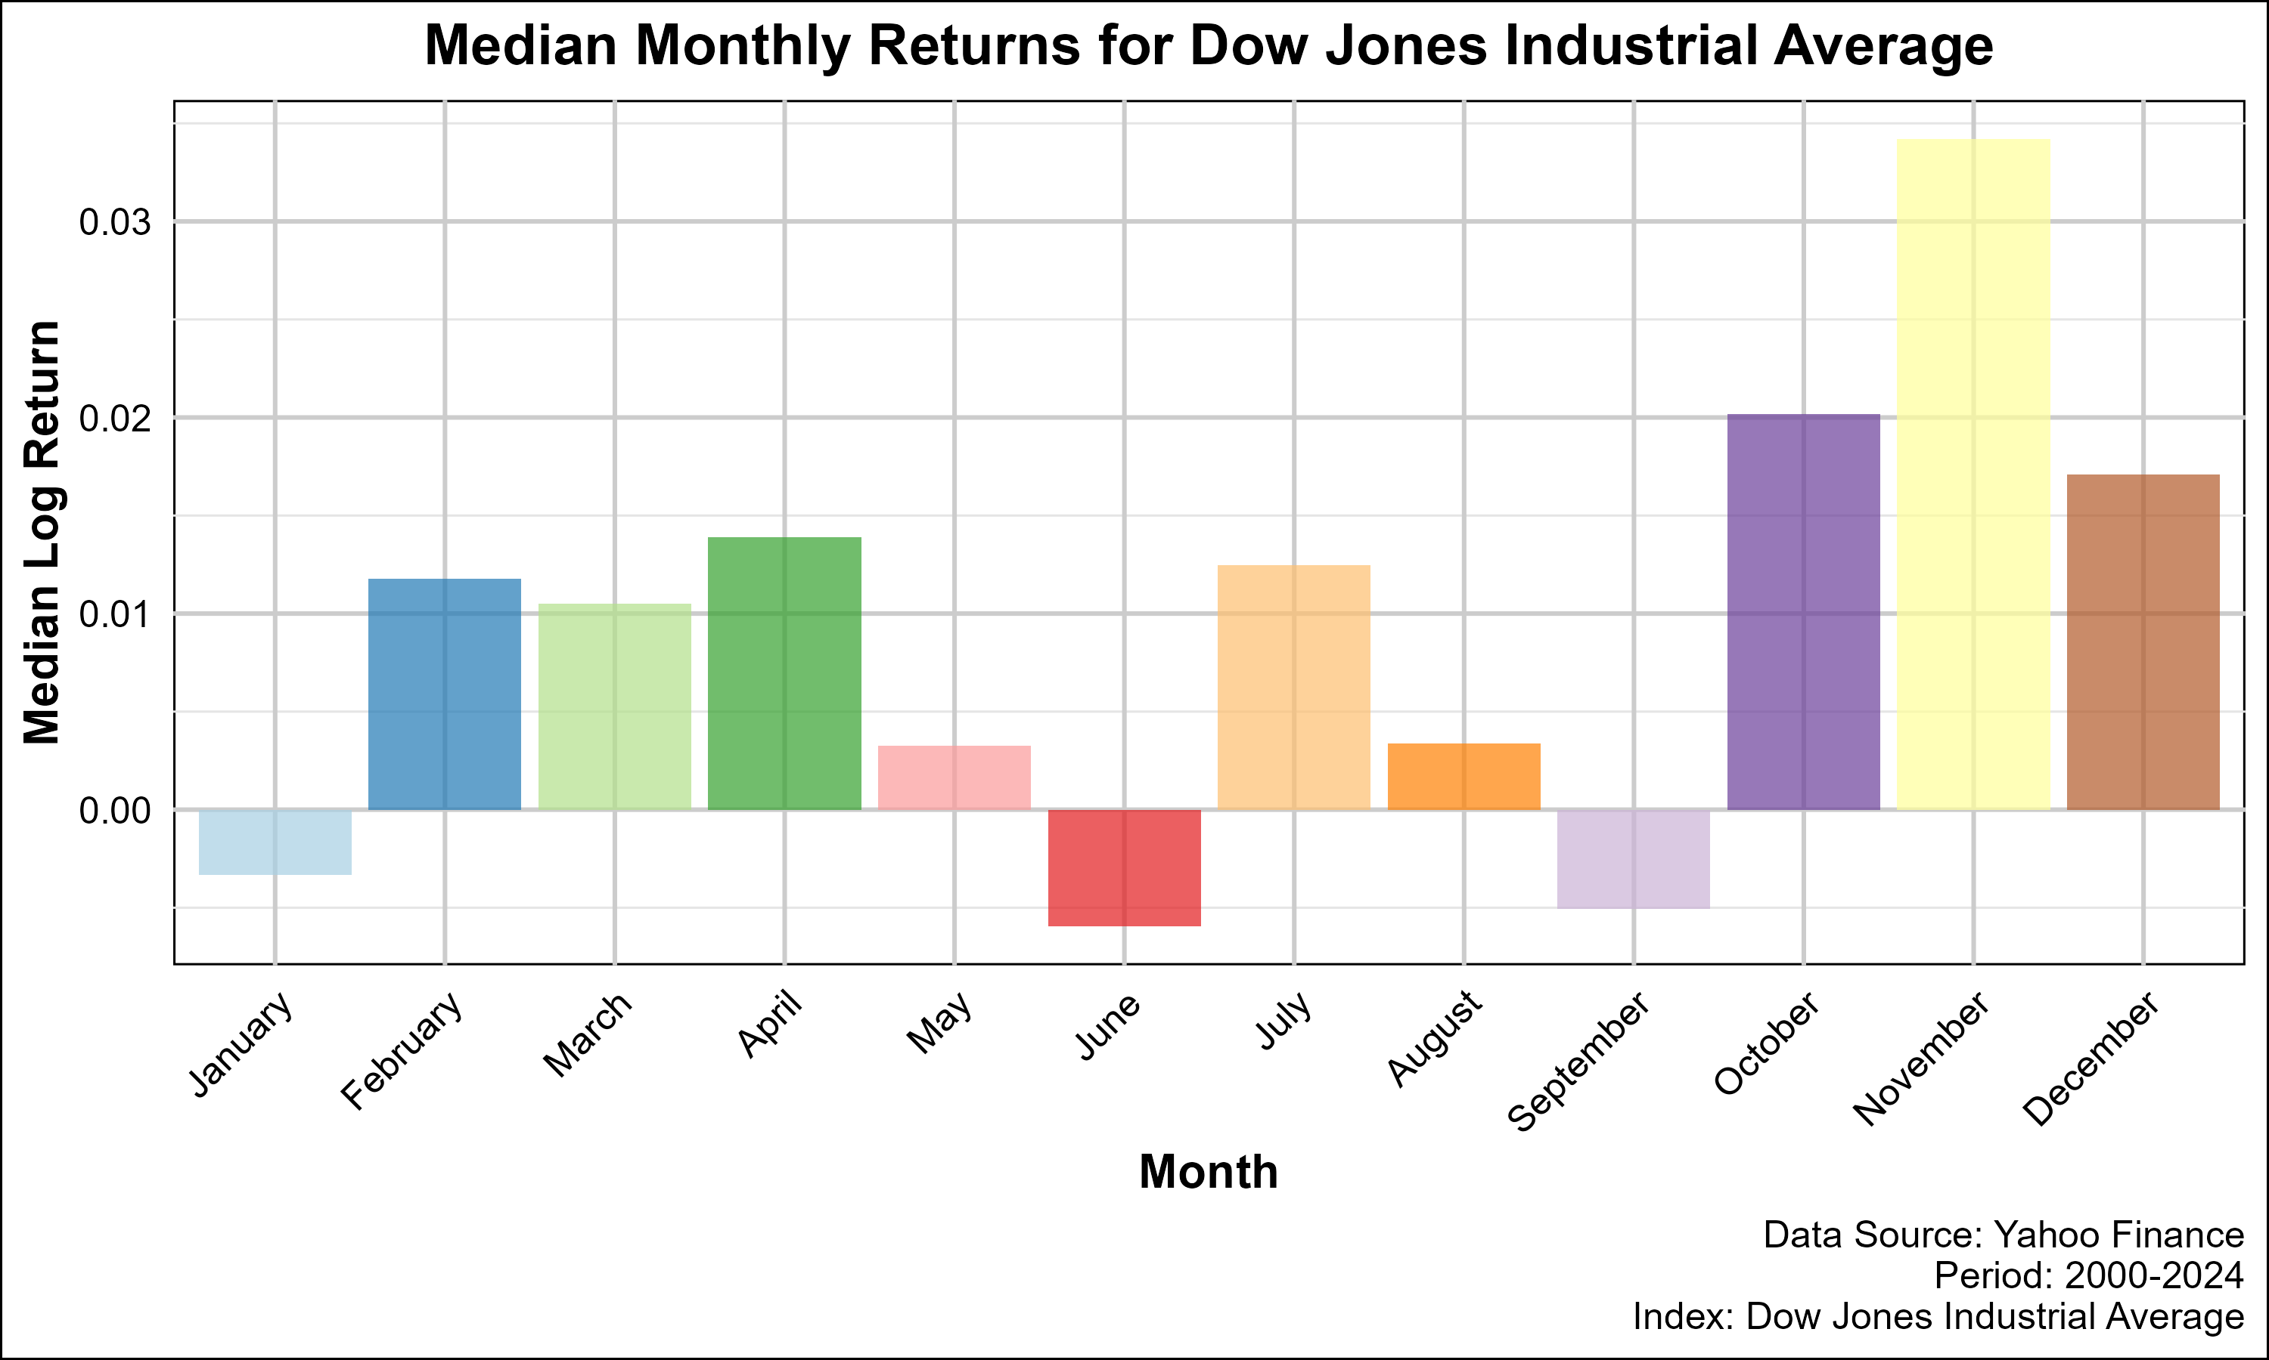

DJIA Median Monthly Returns

1. **Reaffirming Stability:**
   * Median monthly returns highlight the consistent performance of the DJIA, reinforcing its role in reducing portfolio risk.
2. **Strategic Implications:**
   * Median return analysis aids in setting realistic performance expectations, particularly in mean-reversion trades involving the DJIA.

### Summary of Seasonal and Sentiment Analyses

1. **Sentiment Zones:**
   * Correlation matrices highlight the evolving relationships between indices across sentiment environments, providing actionable insights for risk-adjusted hedging.
   * Extreme sentiment zones (very high or very low) offer the most pronounced divergence opportunities but require heightened risk controls.
2. **Seasonal Patterns:**
   * Seasonal biases in returns guide optimal timing for entering and exiting trades, particularly during historically strong or weak months.
3. **Integration with Strategy:**
   * Combining sentiment and seasonal analyses enhances the precision and robustness of the hedged mean-reversion strategy, maximizing returns while managing risks effectively.

### Performance Based on Sentiment

#### VIX Index and Market Sentiment

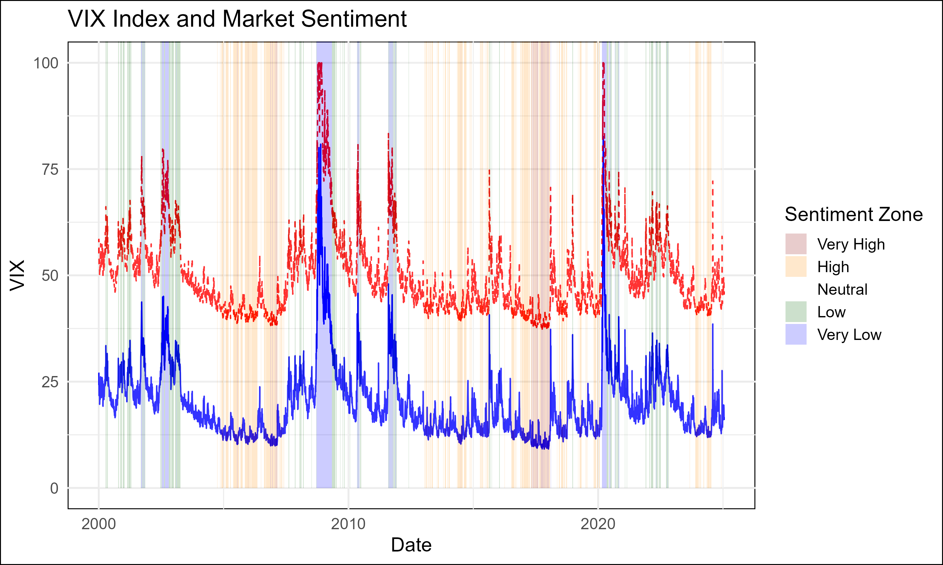

VIX and Market Sentiment

This plot captures the relationship between the **VIX Index** (a measure of market volatility) and corresponding **market sentiment scores**. The shaded regions represent distinct **sentiment zones**, ranging from **Very High** (extreme optimism) to **Very Low** (extreme pessimism). By observing these zones, we can assess how sentiment impacts the performance of the Dow Jones Industrial Average (DJIA) and Nasdaq Composite Index.

1. **Sentiment Classification:**
   * Sentiment zones are derived from Z-scores of the VIX Index and categorized into five levels: Very High, High, Neutral, Low, and Very Low.
   * High VIX levels correspond to negative sentiment (Very Low/Low), while low VIX levels align with positive sentiment (High/Very High).
2. **Strategic Relevance:**
   * In low sentiment zones (high VIX), markets are risk-averse, and divergence opportunities between indices widen due to differing volatility profiles.
   * In high sentiment zones (low VIX), correlations tend to stabilize, reducing mean-reversion opportunities but offering steadier performance for hedged strategies.

#### Performance by Sentiment Zone

The performance of the Dow Jones and Nasdaq indices varies significantly across sentiment zones. Below, we analyze their returns under different sentiment conditions, focusing on overnight, intraday, and total returns.

##### Performance for Dow Jones during Various Sentiment Zones

1. **Very Low Sentiment:**
   * **Overnight Return:** -0.2215477
   * **Intraday Return:** -0.8138126
   * **Total Return:** -0.855062
   * Interpretation:
     + Extreme pessimism leads to broad market sell-offs, with the DJIA experiencing losses both overnight and intraday.
     + Hedged strategies need to account for heightened volatility and the risk of prolonged divergence.
2. **Low Sentiment:**
   * **Overnight Return:** 0.05603467
   * **Intraday Return:** -0.3287334
   * **Total Return:** -0.2911192
   * Interpretation:
     + While overnight returns are mildly positive, intraday returns remain negative, reflecting continued risk aversion.
3. **Neutral Sentiment:**
   * **Overnight Return:** 0.2046669
   * **Intraday Return:** 3.771851
   * **Total Return:** 4.748491
   * Interpretation:
     + In a balanced market environment, the DJIA exhibits strong intraday performance, benefiting from stable economic and corporate conditions.
4. **High Sentiment:**
   * **Overnight Return:** 0.2395033
   * **Intraday Return:** 2.776083
   * **Total Return:** 3.680467
   * Interpretation:
     + Optimistic sentiment fuels positive intraday returns, with overnight gains contributing to a strong total performance.
5. **Very High Sentiment:**
   * **Overnight Return:** 0.07179402
   * **Intraday Return:** 0.2761163
   * **Total Return:** 0.3677338
   * Interpretation:
     + While returns remain positive, the magnitude of gains decreases as markets reach extreme optimism, limiting mean-reversion opportunities.

##### Performance for Nasdaq Composite during Various Sentiment Zones

1. **Very Low Sentiment:**
   * **Overnight Return:** -0.6627893
   * **Intraday Return:** -0.6406212
   * **Total Return:** -0.8788136
   * Interpretation:
     + The tech-heavy Nasdaq is disproportionately affected during market sell-offs, experiencing steep losses in both overnight and intraday sessions.
2. **Low Sentiment:**
   * **Overnight Return:** -0.1816181
   * **Intraday Return:** -0.5734238
   * **Total Return:** -0.6508977
   * Interpretation:
     + Negative sentiment continues to weigh on the Nasdaq, with risk-off behavior driving capital away from growth-oriented stocks.
3. **Neutral Sentiment:**
   * **Overnight Return:** 10.32978
   * **Intraday Return:** -0.2205495
   * **Total Return:** 7.831003
   * Interpretation:
     + Overnight returns dominate during neutral sentiment, indicating that pre-market activity and global news are key drivers of performance.
4. **High Sentiment:**
   * **Overnight Return:** 1.138685
   * **Intraday Return:** 2.83902
   * **Total Return:** 7.210455
   * Interpretation:
     + Both overnight and intraday returns are robust, reflecting strong investor confidence in growth-oriented sectors.
5. **Very High Sentiment:**
   * **Overnight Return:** 0.1808935
   * **Intraday Return:** 0.2945276
   * **Total Return:** 0.5286992
   * Interpretation:
     + Similar to the DJIA, extreme optimism limits further upside for the Nasdaq, with diminishing returns during very high sentiment periods.

#### Performance Summary for Nasdaq

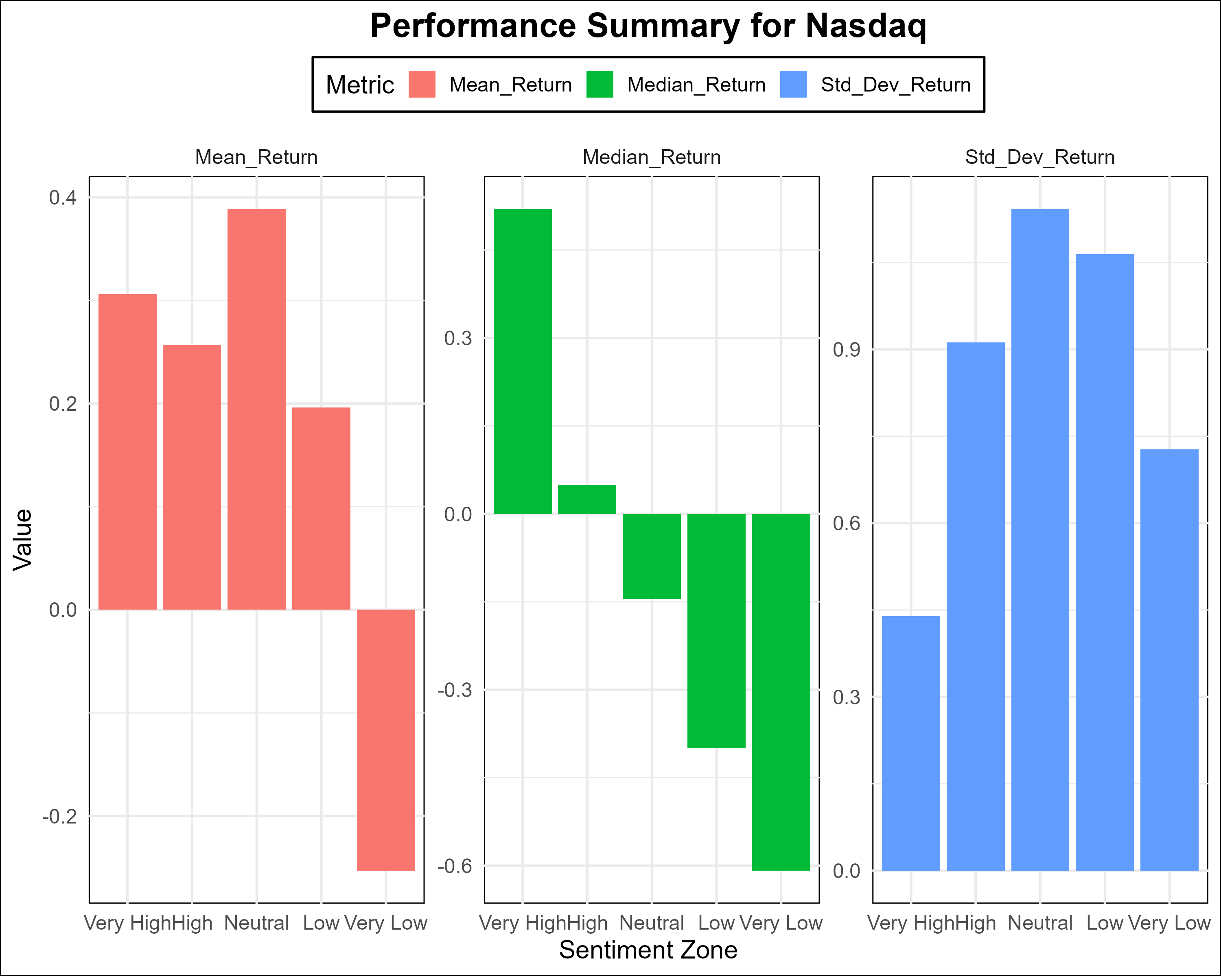

Performance Summary for Nasdaq

This bar plot summarizes the **average** and **median returns** for the Nasdaq Composite across sentiment zones, providing an aggregated view of performance trends.

1. **Key Insights:**
   * Average returns are significantly higher during neutral and high sentiment zones, driven by strong overnight performance.
   * Median returns, while lower, align closely with averages, indicating consistency in performance across periods.
2. **Implications for Strategy:**
   * The mean-reversion strategy benefits most from neutral and high sentiment zones, where performance differences between indices are most pronounced.

#### Performance Bar Charts

##### Dow Jones Performance by Sentiment Zone

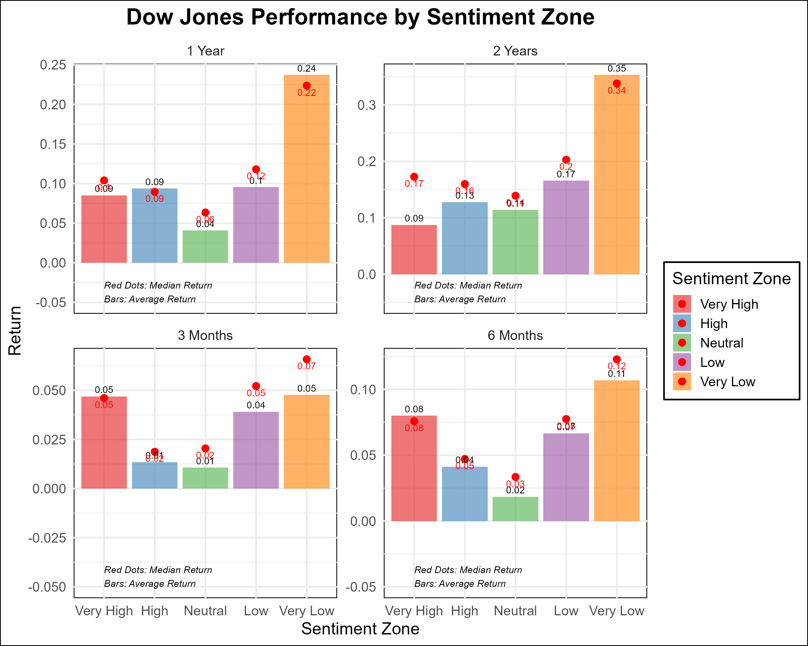

Dow Performance Bar Chart

1. **Characteristics:**
   * Positive returns dominate high and neutral sentiment zones, while negative returns are evident in low and very low zones.
   * Overnight and intraday performance patterns align with broader market trends, providing opportunities for selective hedging.

##### Nasdaq Performance by Sentiment Zone

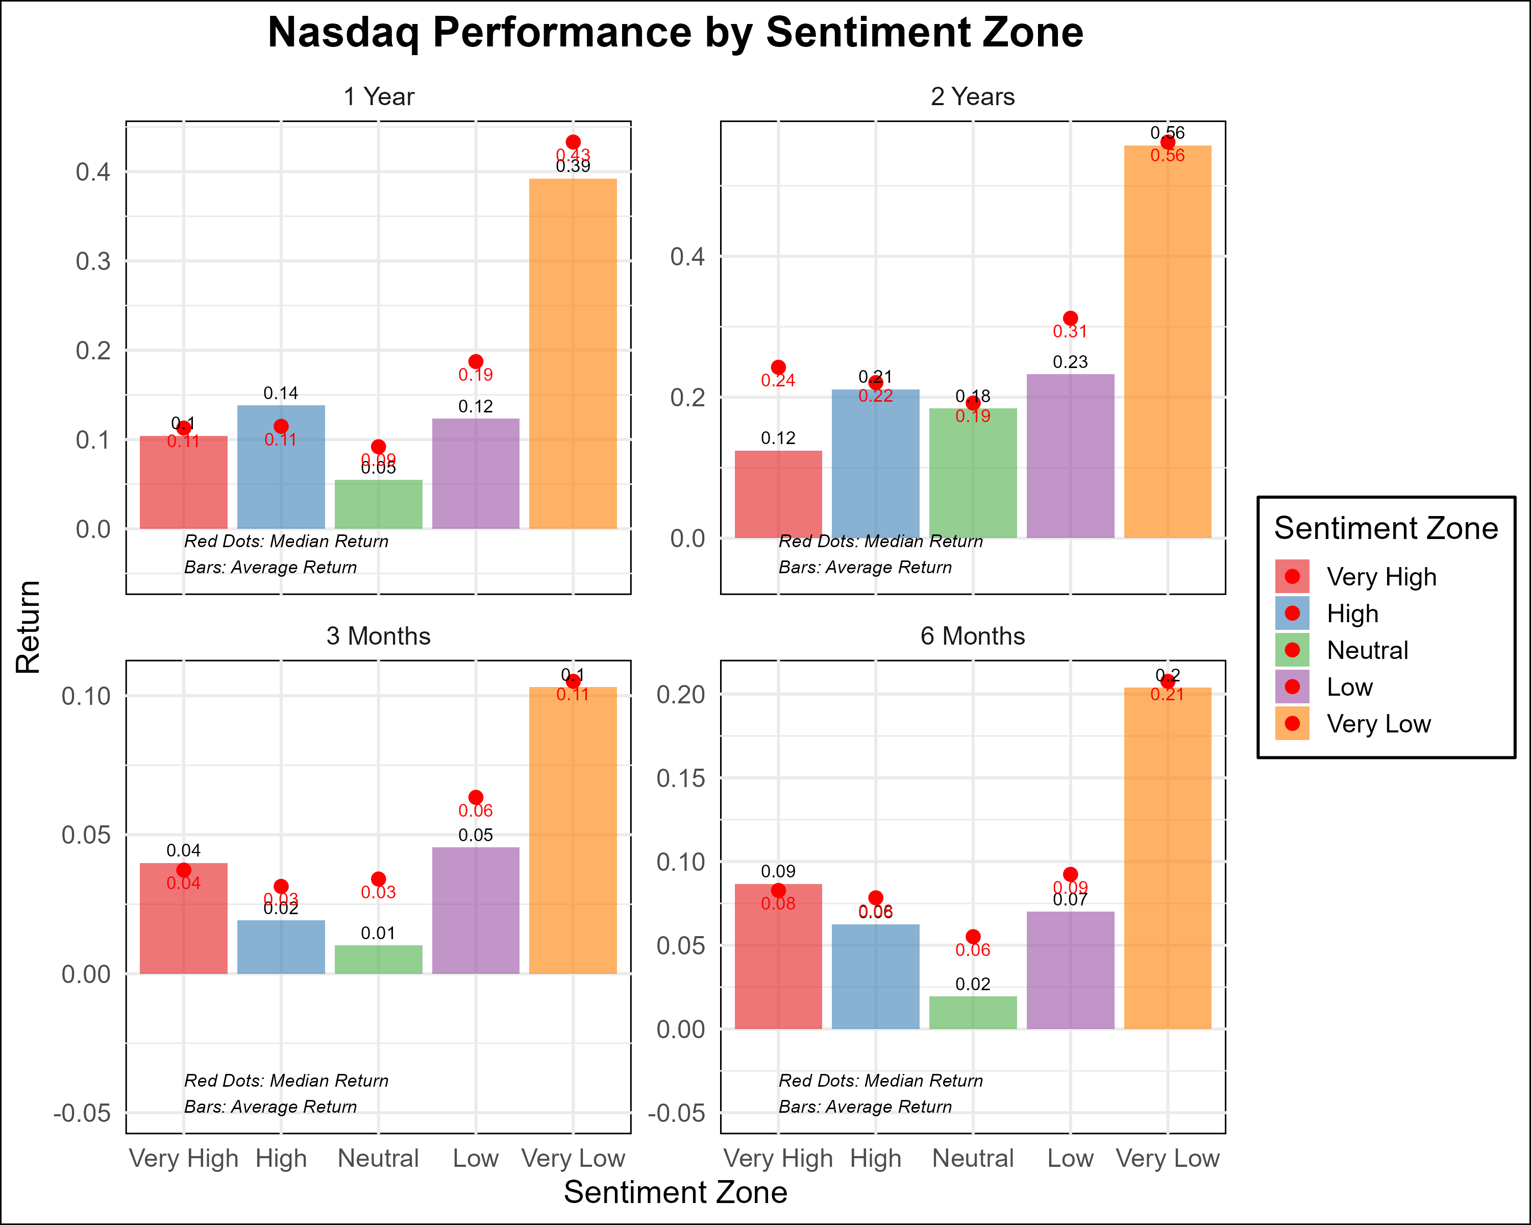

Nasdaq Performance Bar Chart

1. **Characteristics:**
   * Similar to the DJIA, the Nasdaq shows strong performance in high and neutral sentiment zones but suffers steep losses during very low sentiment.
   * The Nasdaq’s higher volatility amplifies both risks and rewards in these zones.

#### Performance Boxplots

##### Dow Jones Performance by Sentiment Zone

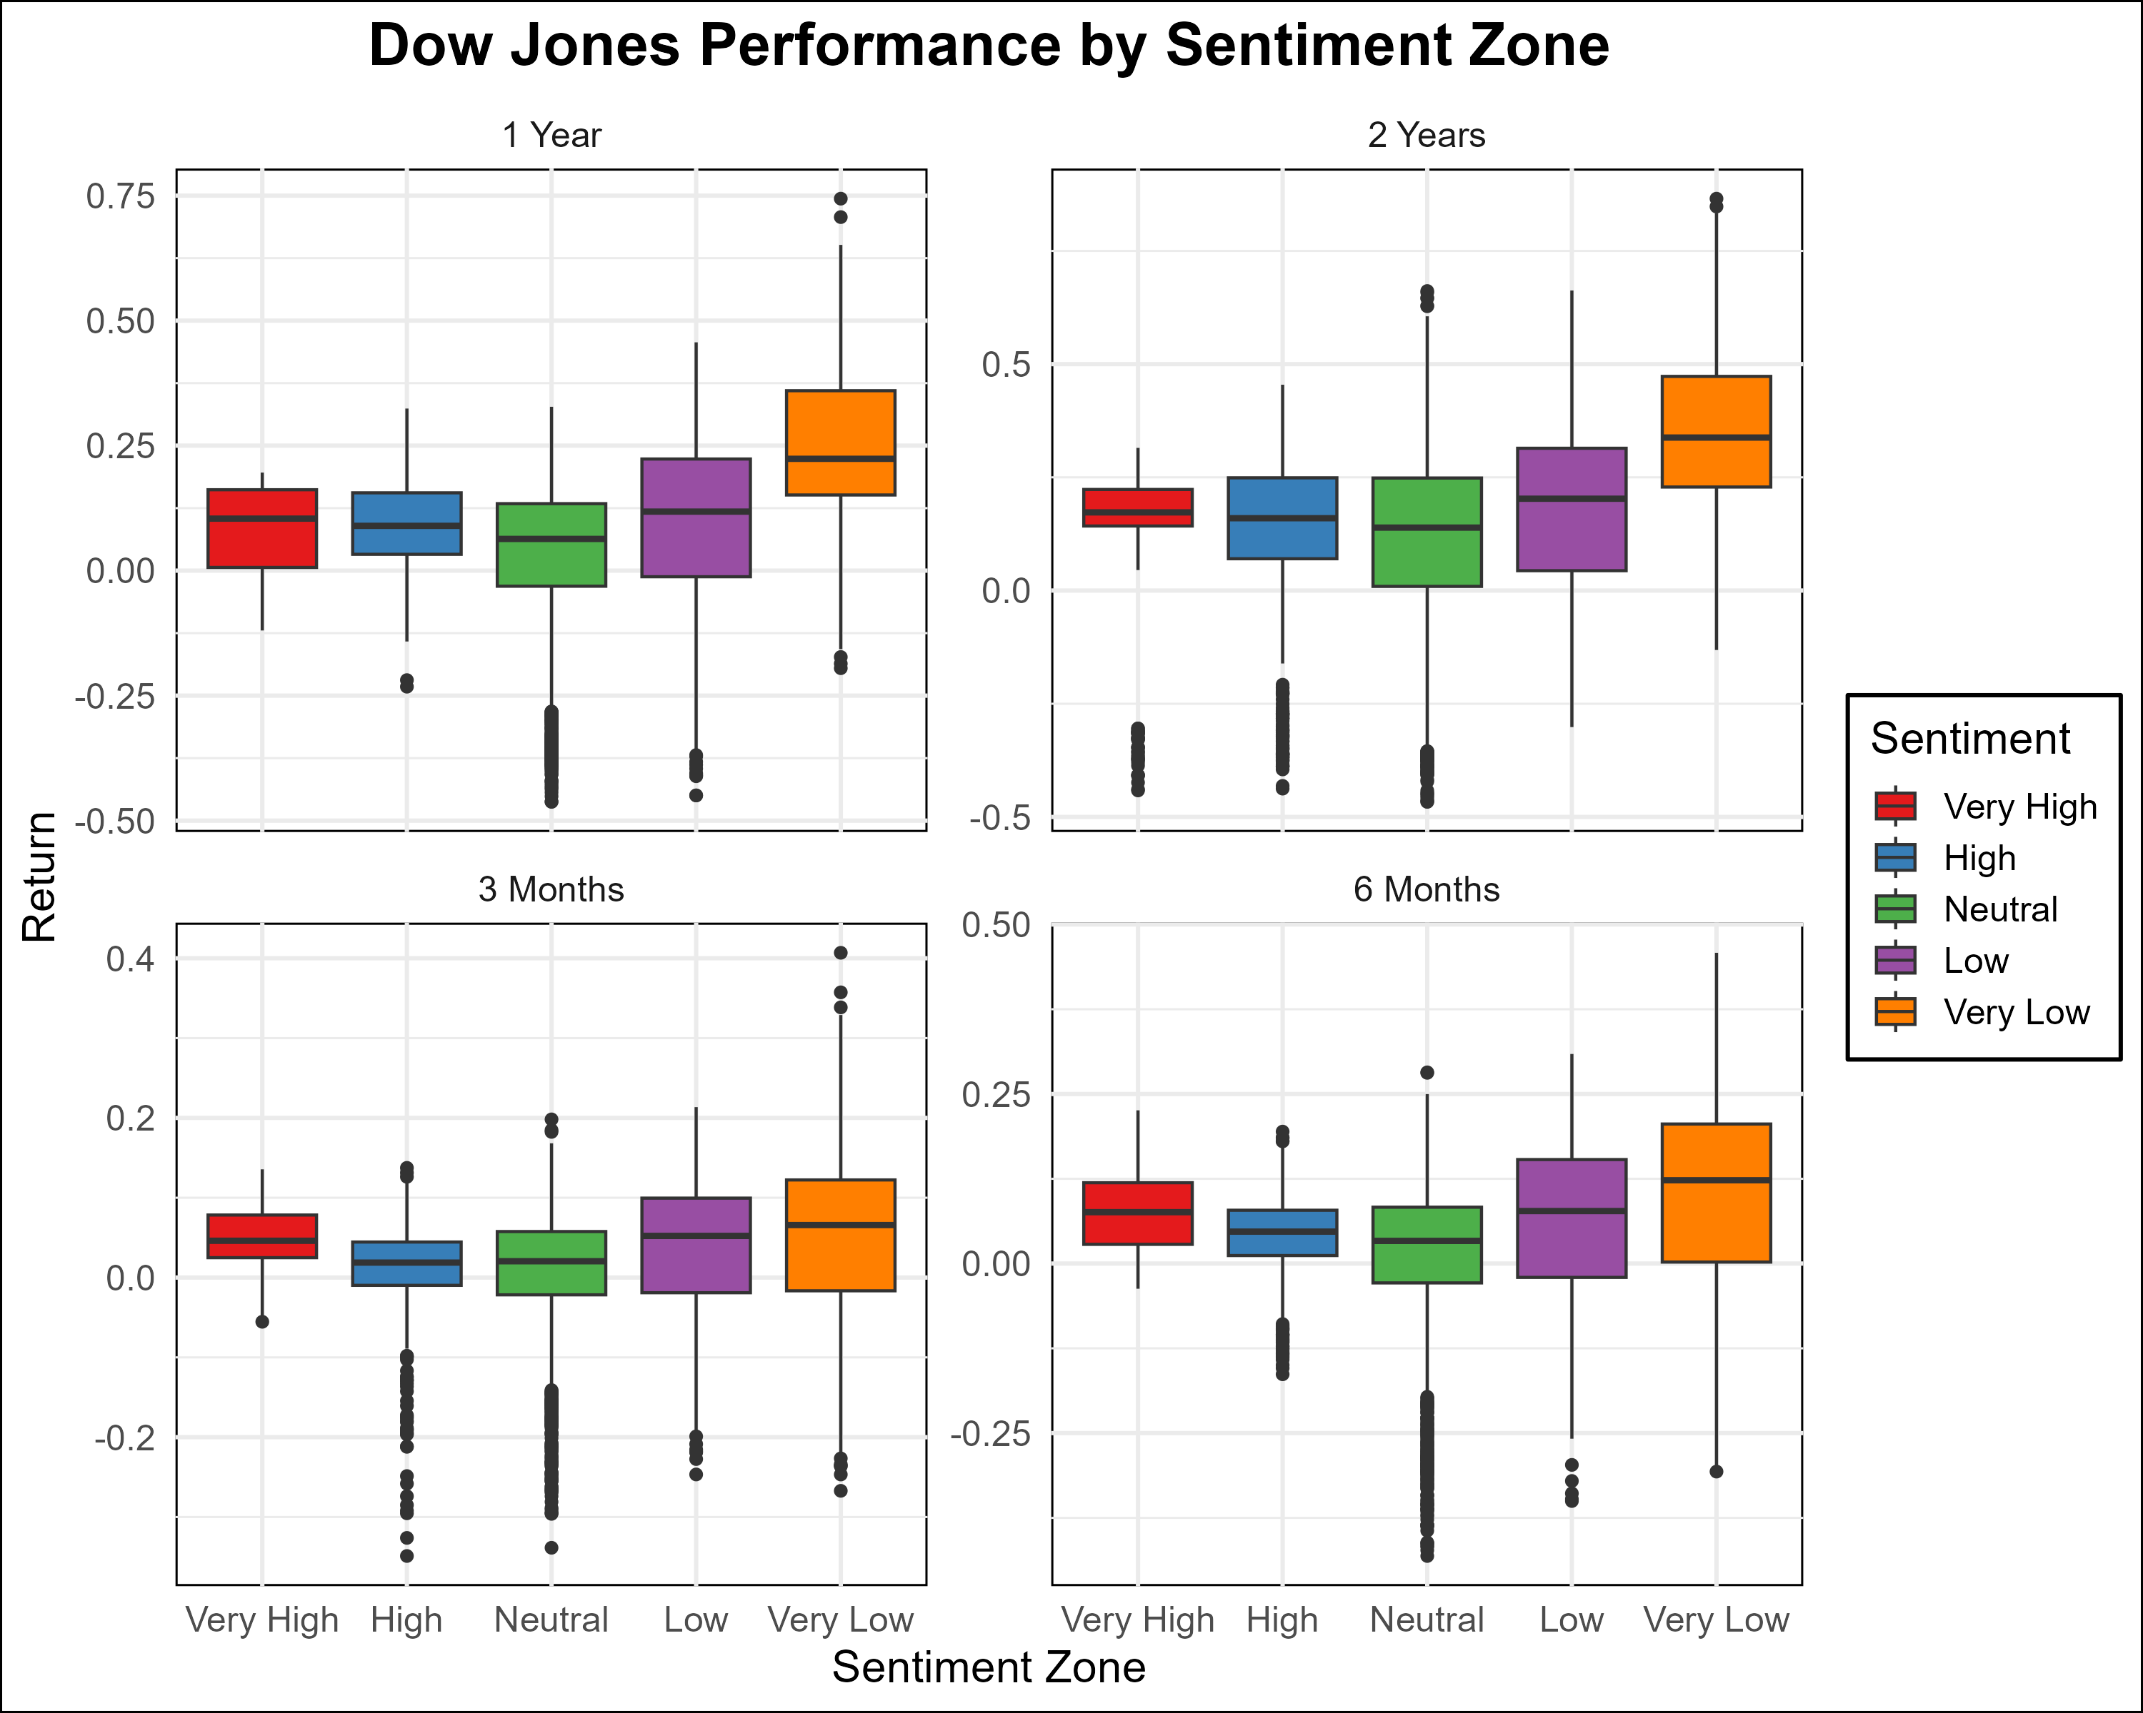

Dow Performance Boxplot

1. **Distribution Analysis:**
   * The boxplots highlight the variability in DJIA returns across sentiment zones, with wider interquartile ranges (IQRs) in high and very low zones.
   * Outliers are more frequent during low and very low sentiment, reflecting tail risks.

##### Nasdaq Performance by Sentiment Zone

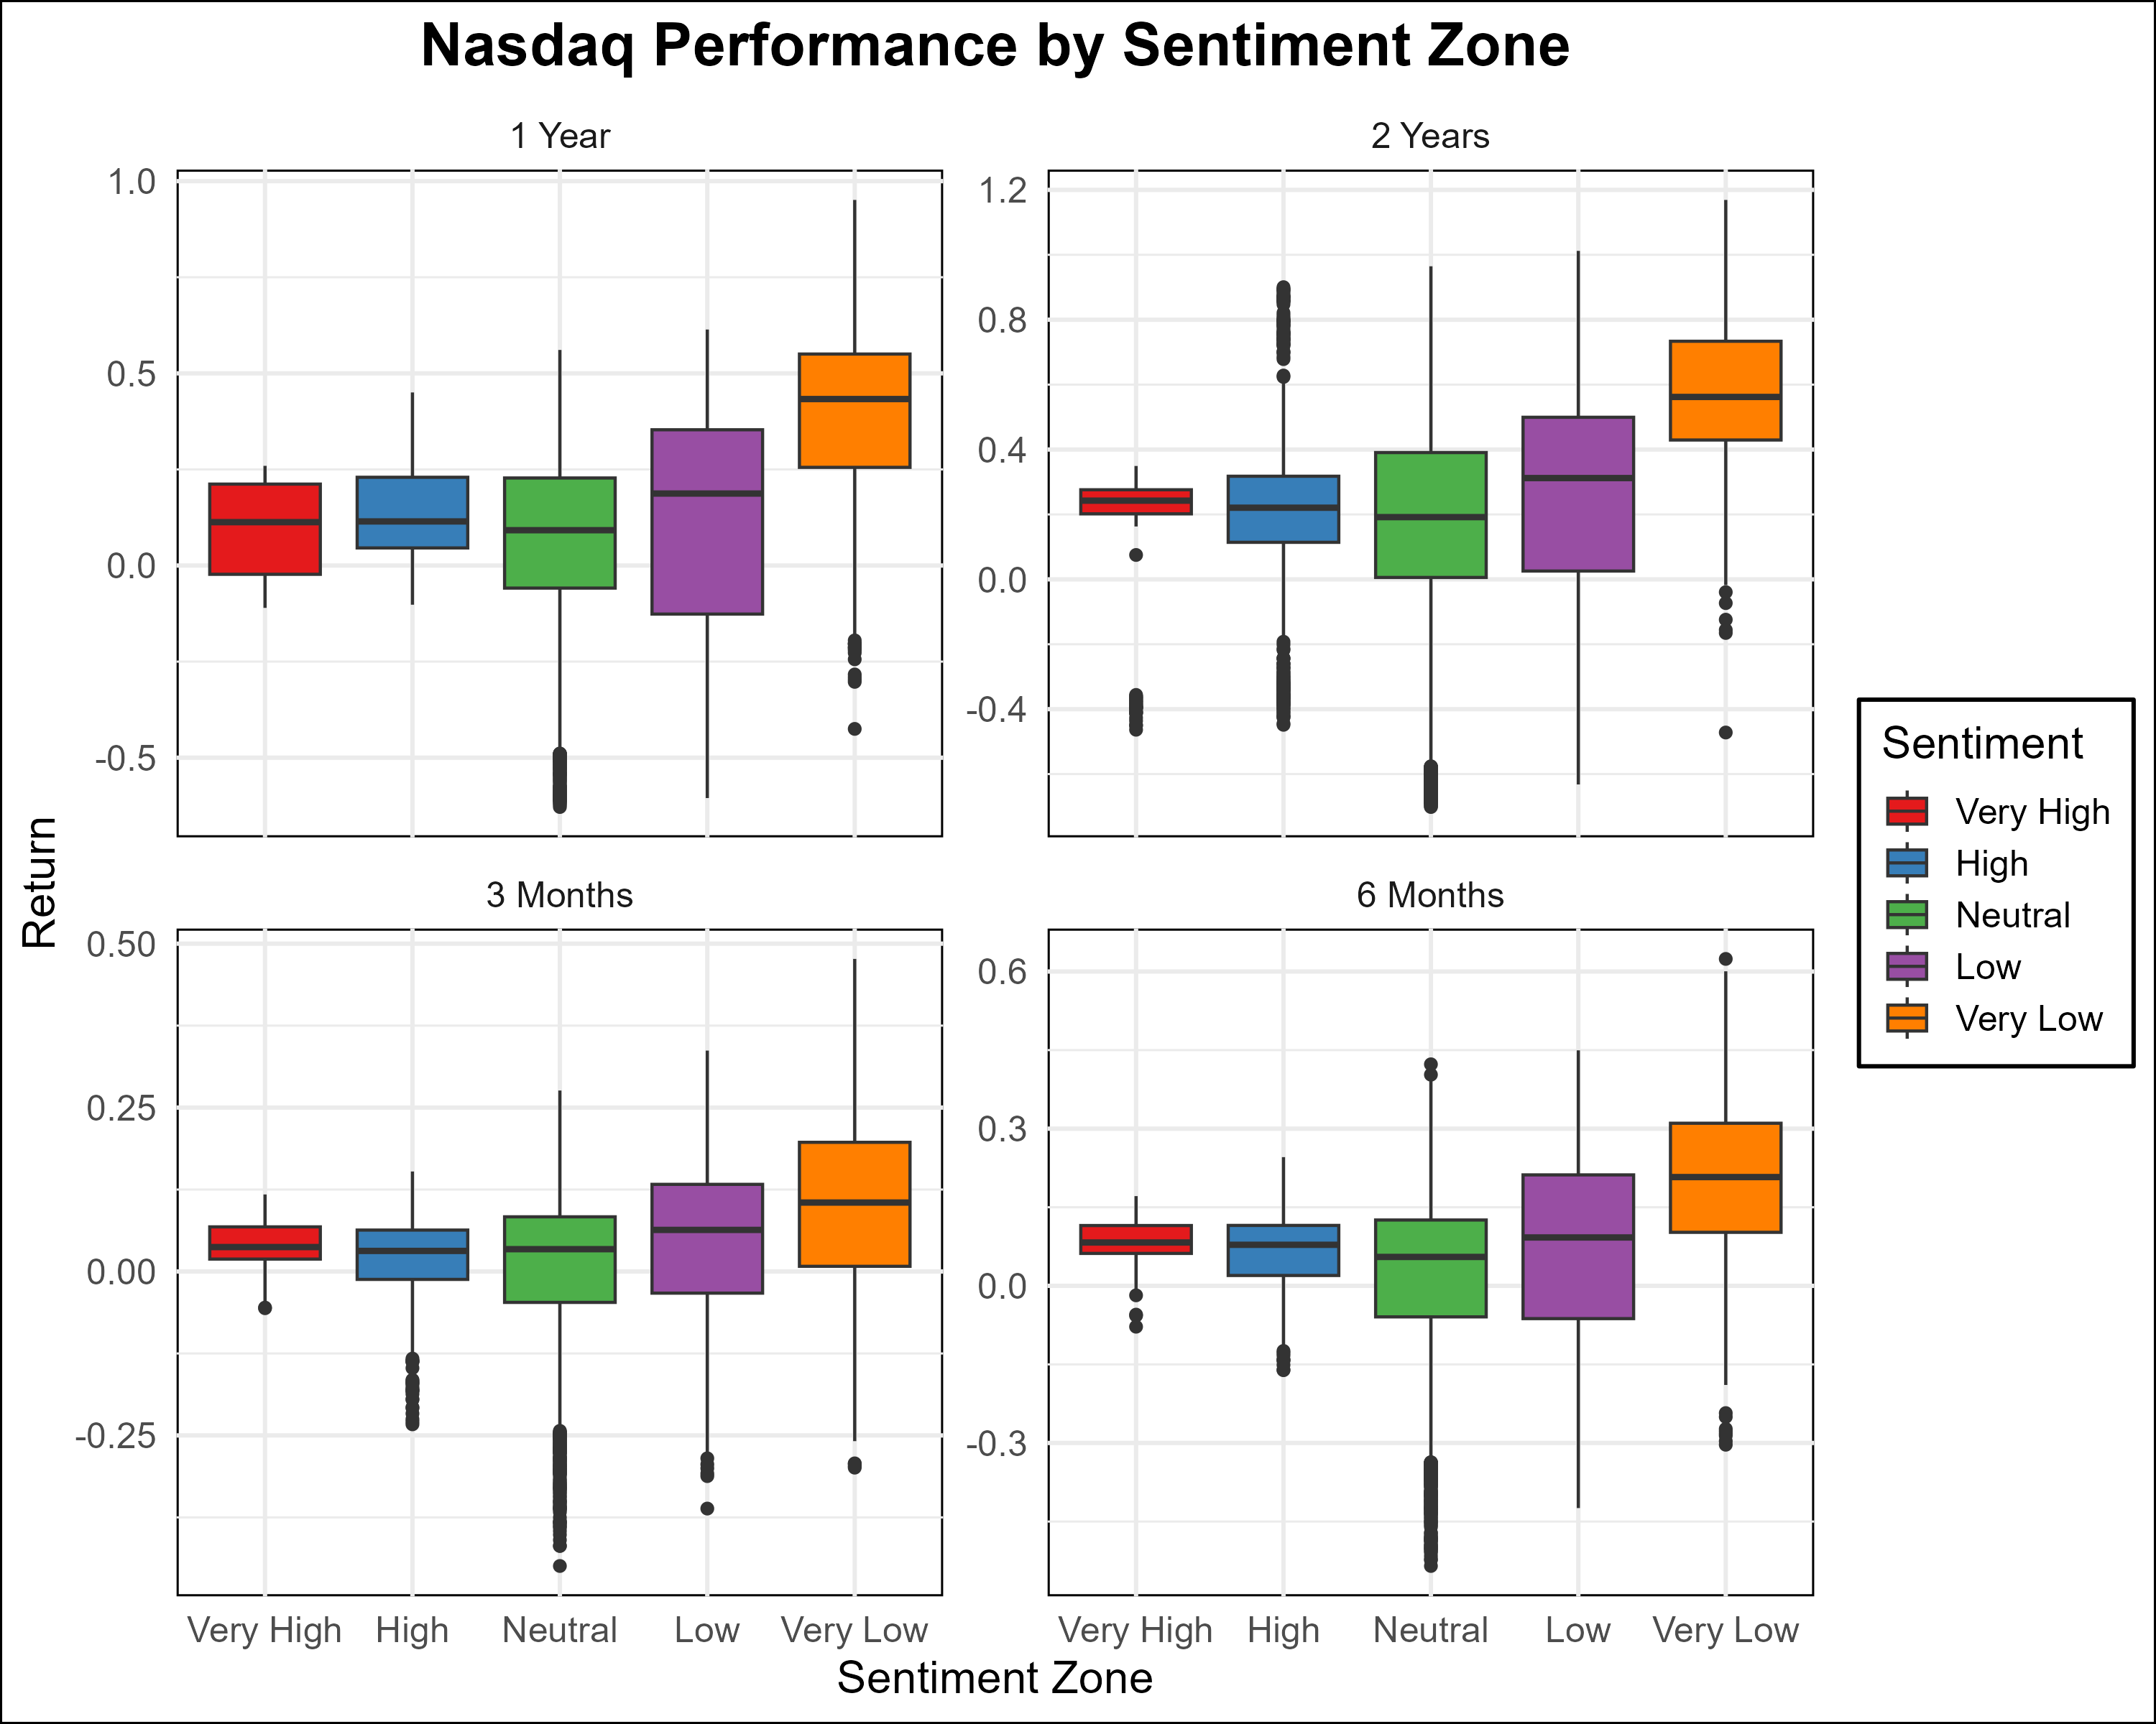

Nasdaq Performance Boxplot

1. **Distribution Analysis:**
   * Nasdaq returns exhibit greater dispersion compared to the DJIA, particularly in low and very low sentiment zones.
   * The presence of extreme outliers in these zones underscores the importance of hedging and risk controls in the strategy.

### Summary and Strategic Insights

1. **Sentiment-Based Performance:**
   * The VIX and sentiment analysis confirm that both indices perform best in neutral and high sentiment zones, with opportunities for mean-reversion trades emerging during extreme conditions.
   * Divergence is most significant in very low sentiment zones, though these periods carry higher risks.
2. **Hedged Strategy Alignment:**
   * During very low sentiment, the strategy should prioritize conservative position sizing and tighter hedges to mitigate risks.
   * Neutral and high sentiment zones offer the most stable environment for exploiting mean-reversion opportunities.
3. **Actionable Steps:**
   * Incorporate sentiment analysis into the timing of trades.
   * Monitor rolling correlations and VIX trends to anticipate changes in sentiment zones.
   * Use boxplot and bar chart insights to refine expectations for return variability and optimize hedge ratios dynamically.

### Interactive Visualizations of Nasdaq and Dow Jones Analysis

#### Volatility (VIX) vs. Market Indices (Nasdaq and Dow Jones)

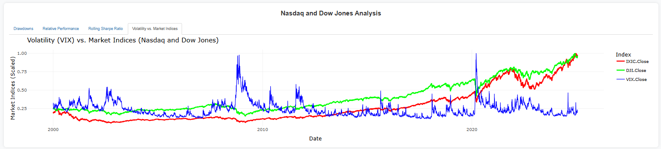

Volatility vs. Market Indices

This Shiny App interactive visualization showcases the relationship between the Volatility Index (VIX) and the Nasdaq and Dow Jones closing prices. The VIX (blue line) represents market volatility scaled for visualization, while the Nasdaq (red line) and Dow Jones (green line) lines represent the scaled index values.

Key Insights: - **Volatility Cycles:** The chart highlights the periods of high and low volatility, particularly during financial crises, economic downturns, or significant geopolitical events. - **Market Reaction to Volatility:** The relationship between market indices and volatility is evident. For instance, spikes in VIX typically coincide with drops in both indices, signaling heightened uncertainty. - **Hedged Strategy Implications:** During high-volatility periods, the hedged mean reversion strategy may be tested more rigorously as both indices are more prone to diverging movements. Volatility impacts both returns and risk assessments.

#### Rolling Sharpe Ratio Over Time

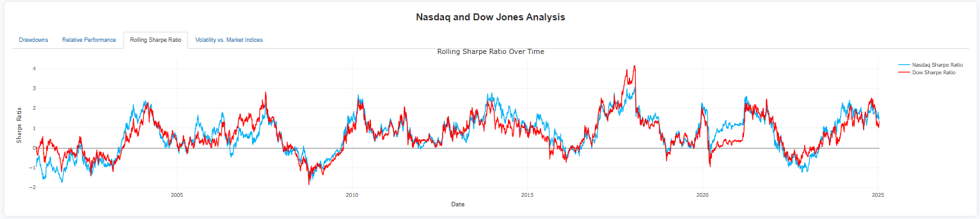

Rolling Sharpe Ratio

This visualization represents the rolling Sharpe Ratio for both Nasdaq (blue) and Dow Jones (red) over time, which measures the risk-adjusted return of each index.

Key Insights: - **Performance Trends:** Peaks and troughs in the Sharpe Ratio indicate periods of superior and inferior risk-adjusted returns for each index. - **Interplay Between Indices:** The alternating patterns highlight the varying performance dynamics between the two indices, which could be exploited in the hedged mean reversion strategy. - **Strategic Utility:** Periods of significant divergence in risk-adjusted performance may offer opportunities to fine-tune the hedged strategy by adjusting position weights or entry thresholds.

#### Relative Performance of Nasdaq vs. Dow Jones

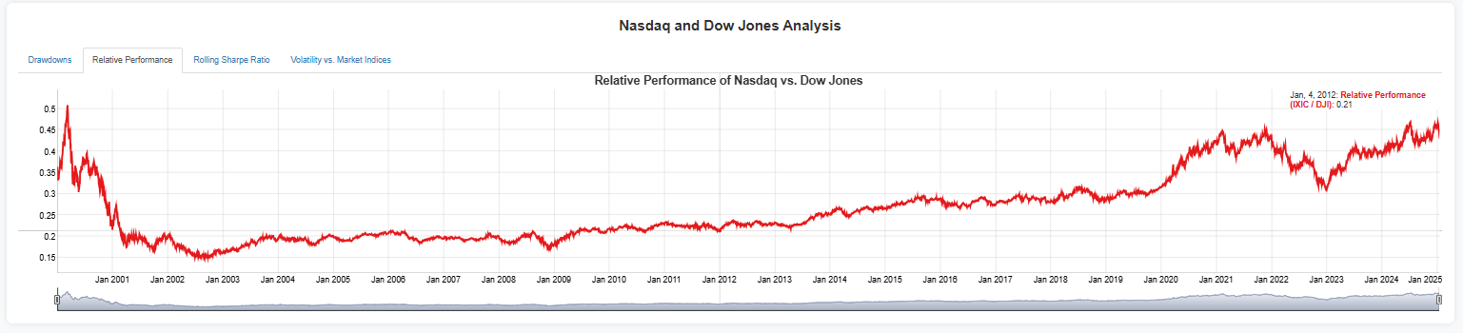

Relative Performance

This visualization tracks the relative performance ratio of Nasdaq to Dow Jones over time. A rising line indicates Nasdaq outperforming Dow Jones, while a declining line shows the opposite.

Key Insights: - **Long-Term Trends:** Over the last two decades, Nasdaq has generally outperformed Dow Jones, particularly post-2010, driven by the tech boom and innovation in growth sectors. - **Periods of Reversion:** The chart captures cycles of underperformance and outperformance, essential for identifying mean-reverting opportunities within the strategy. - **Hedged Strategy Context:** Monitoring the relative performance ratio aids in determining extreme deviations from the mean, ideal entry points for executing the hedged positions.

#### Drawdowns of Nasdaq and Dow Jones

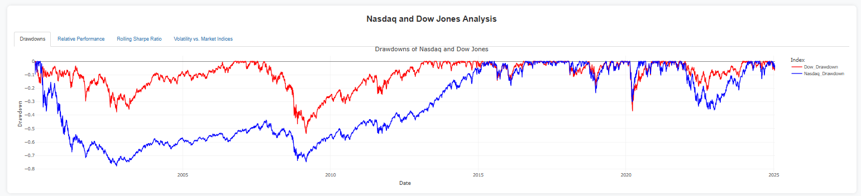

Drawdowns

This visualization highlights the drawdowns of Nasdaq (blue) and Dow Jones (red), showing the percentage decline from the previous peak for each index over time.

Key Insights: - **Drawdown Analysis:** The magnitude and duration of drawdowns reflect market risk and resilience. Nasdaq exhibits more severe drawdowns due to its growth-oriented nature. - **Crisis Periods:** Drawdowns during events like the 2008 financial crisis and the COVID-19 pandemic are clearly visible, providing context for stress-testing strategies. - **Strategic Application:** Understanding drawdown dynamics allows for better calibration of the hedged strategy to manage periods of high market stress, ensuring portfolio stability.

### General Correlation

#### General Correlation between Nasdaq and Dow Jones

* **Correlation:** 0.9821863

The correlation coefficient of 0.9821863 indicates an exceptionally strong linear relationship between the Nasdaq Composite Index (IXIC) and the Dow Jones Industrial Average (DJIA). Despite their distinct sector compositions—Nasdaq being heavily weighted toward technology and growth stocks and the Dow representing a broader industrial and blue-chip portfolio—both indices exhibit synchronized movements.

This strong correlation is critical for implementing a **hedged mean-reversion strategy**. When the correlation temporarily deviates, such events signal potential trading opportunities where a paired strategy (selling one index while buying the other) can exploit the reversion to the mean.

1. **Implications for Strategy Design:**
   * **Hedging Opportunities:** The near-perfect correlation underlines the viability of leveraging deviations between the two indices for mean-reversion trades.
   * **Diversification Challenges:** With correlation this high, independent diversification benefits are limited unless additional uncorrelated instruments are introduced.
   * **Timing Sensitivity:** Given the strong correlation, timing trades precisely at correlation extremes is vital to maximizing returns.

## Conclusion

### Summary of Insights

This documentation provides a quantitative analysis of the Dow Jones Industrial Average and Nasdaq Composite Index, covering historical market trends, correlation dynamics, and sentiment-based performance. Below, we summarize the key findings and their implications for a hedged mean-reversion trading strategy.

#### Key Findings

1. **Market Dynamics:**
   * Both indices exhibit strong positive correlation over time, but temporary divergences present profitable opportunities for mean-reversion strategies.
   * **Cumulative returns** show that Nasdaq outperforms the Dow over longer periods due to its technology focus, though this comes with increased volatility.
2. **Volatility Insights:**
   * Rolling 30-day volatility highlights periods of heightened market stress where divergence opportunities are amplified. Nasdaq’s higher volatility relative to the Dow reinforces its role as the more reactive leg in the hedged strategy.
3. **Sentiment-Based Performance:**
   * Market sentiment, derived from the VIX index, directly influences index performance:
     + **Low and Very Low Sentiment Zones:** Risk-averse behavior drives higher divergence, increasing mean-reversion opportunities.
     + **Neutral Sentiment Zones:** Stable economic conditions foster synchronized movements, offering steady intraday trading opportunities.
   * **Tail Risk Management:** During Very Low sentiment, extreme market conditions require tighter hedges and risk mitigation protocols.
4. **Correlation Analysis:**
   * The rolling 30-day correlation plot reveals cyclical patterns in index relationships. These fluctuations should guide dynamic adjustments to hedge ratios.
5. **Seasonal Trends:**
   * Monthly and quarterly return distributions reveal consistent patterns, such as Nasdaq’s stronger returns during tech-earnings-heavy periods. These insights allow for seasonal positioning adjustments.

#### Strategic Recommendations

1. **Hedged Mean-Reversion Strategy Optimization:**
   * Implement a **pair trade** structure where deviations from the correlation mean signal opportunities:
     + **Buy the underperforming index** (e.g., Dow) and **sell the outperforming index** (e.g., Nasdaq) during extreme divergence.
   * **Monitor Sentiment Zones:** Use VIX-based sentiment analysis to time entries during heightened divergence in Very Low and Low sentiment zones.
2. **Dynamic Hedge Ratios:**
   * Adjust hedge ratios dynamically based on rolling correlation and volatility trends. During high volatility, reduce exposure to mitigate risks while amplifying hedge efficiency.
3. **Risk Management Protocols:**
   * Incorporate stop-loss and profit-taking mechanisms based on statistical thresholds derived from historical standard deviations of the correlation.
   * Use Nasdaq’s higher volatility as a guide for position sizing, with smaller relative positions in the Nasdaq to equalize risk exposure.
4. **Seasonal Positioning:**
   * Leverage the seasonal trends identified in the monthly and quarterly analysis for entry and exit timing, particularly in earnings-heavy months for Nasdaq.
5. **Enhanced Monitoring:**
   * Use real-time tracking of rolling correlations and sentiment indicators to anticipate market regime changes. Combine these with overnight and intraday performance metrics to fine-tune trading decisions.

### Broader Implications and Next Steps

1. **Integration of Advanced Models:**
   * Incorporate machine learning to forecast correlation breakpoints or shifts in sentiment zones.
   * Use factor models to quantify sector-specific contributions to index performance.
2. **Expand Universe of Assets:**
   * Add complementary indices or ETFs with lower correlations to diversify the strategy further while retaining mean-reversion focus.
3. **Automated Execution:**
   * Design a fully automated trading system to monitor and execute trades based on the strategy’s quantitative signals in real-time.

This quantitative research has laid a robust foundation for implementing a hedged mean-reversion strategy. By combining meticulous data analysis, sentiment dynamics, and statistical rigor.